
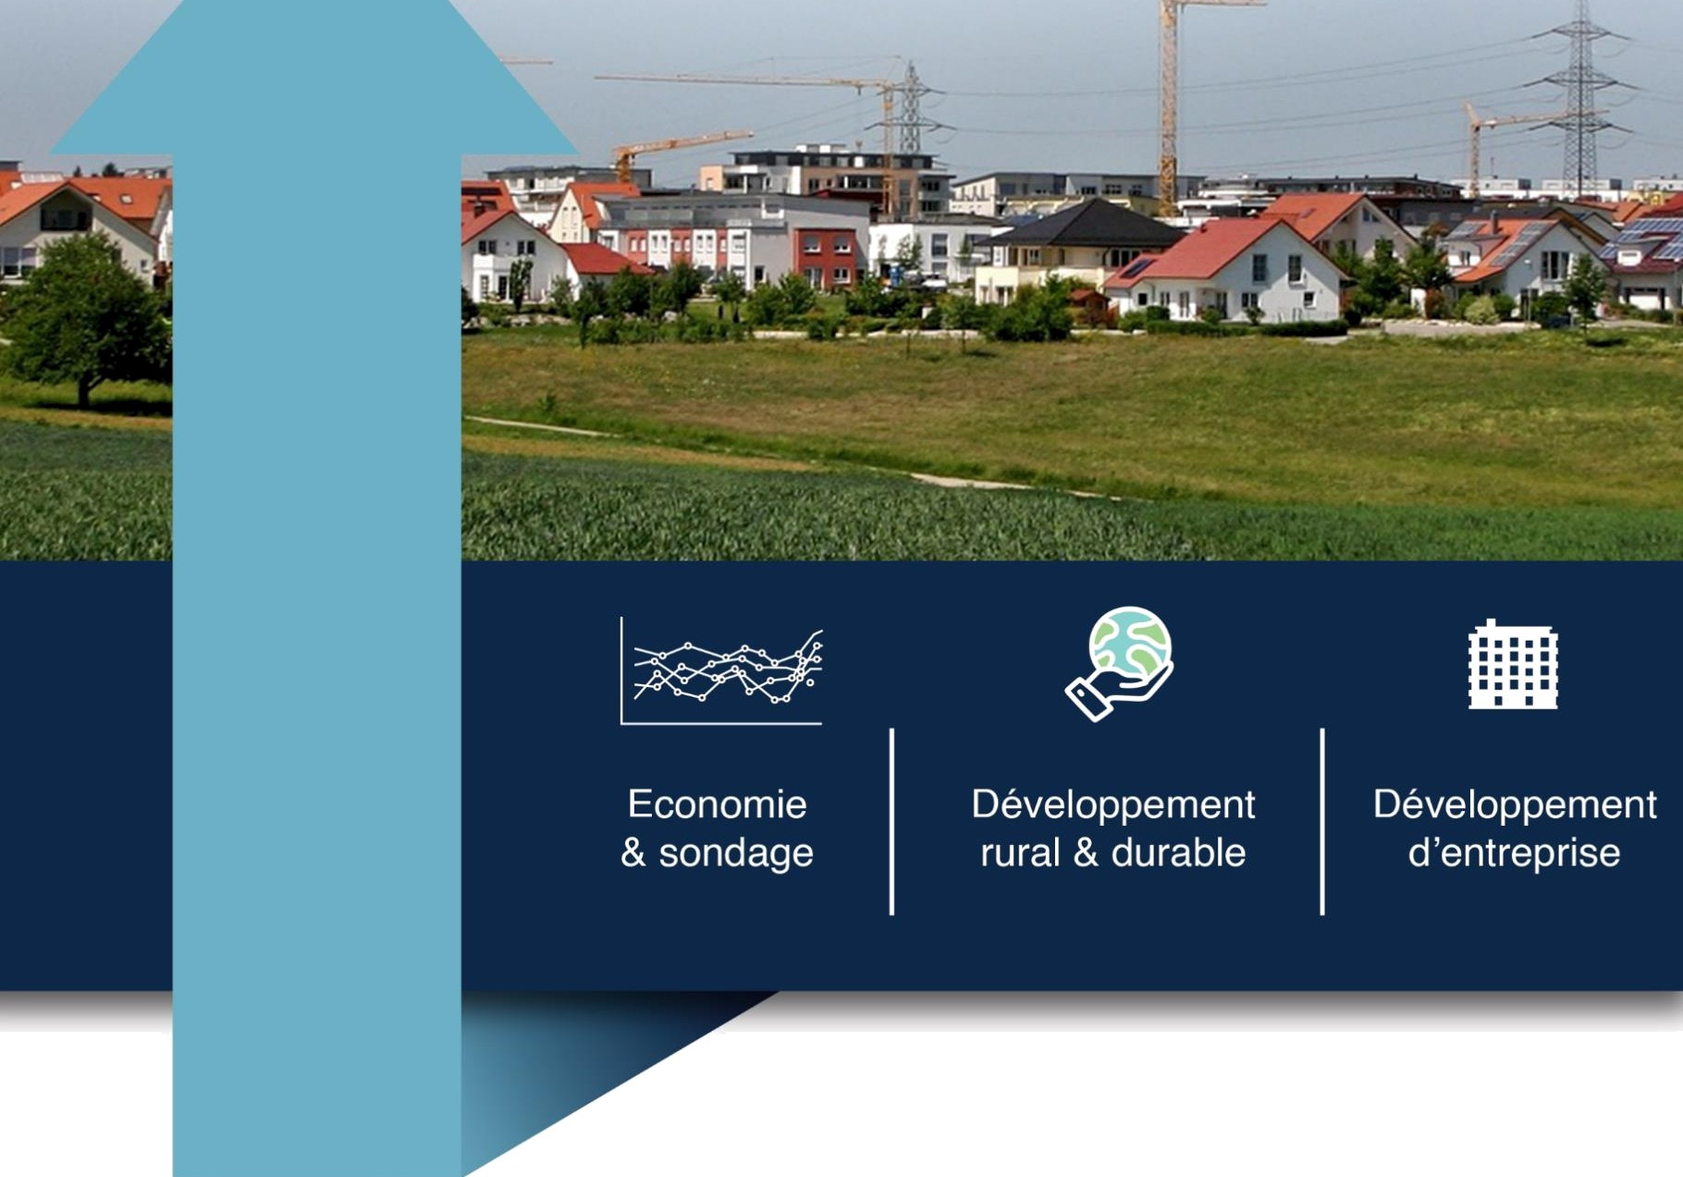
Consultancy firm

12 Rue Rainitovo (face ETP), Tel : 034 85 308 19, Email : a.zavamanitraOgmaiI.com Nif : 6001374994 - Stat : 56101112013005895 - RCS : Antananarivo 2013 A 01157 ANDRIAMIHARIVOLAMENA Liva Zavamanitra 00008 00004 05001133007 32


UPDATE ON THE 2012-2013 NATIONAL FRAMEWORK SURVEY
ON SMALL-SCALE SEA FISHING AND INLAND FISHING
PROVISIONAL FINAL REPORT

Report presented by :


On behalf of the SWIOFISH 2 Project

Activity code: 2121340

TABLE OF CONTENTS
TABLE OF CONTENTS 1
FOREWORD 3
- Understanding the mandate 4
  - Context 4
  - Importance of fishing in the national economy 4
  - The social importance of fishing 4
  - Sector issues. 4
- OBJECTIVE OF THE MISSION 5
  - Overall objective 5
  - Specific objectives 5
- METHODOLOGY 6
  - The survey model 6
    - Structure of the National Framework Survey 6
    - Study area 7
    - Primary units 8
    - Survey duration and questionnaire 8
  - Operationalising data collection 9
    - Pre-survey questionnaire 9
    - Household survey questionnaire 9
    - Focus group 9
  - Organisation of the collection 10
    - Recruitment and training of agents 10
    - Default coverage management 13
  - Themes and production of indicators 13
- Data analysis and processing 13
  - Database creation 13
  - Analysis by theme 13
  - Supports 13
- CHRONOGRAMME and MONITORING OF ACTIVITIES 14
  - Schedule of activities 14
  - Monitoring data collection operations 16
- STRUCTURE OF THE ECN AND MAIN RESULTS 17
  - Fishing villages and their environment Error ! Bookmark not defined.
    - Distribution of fishing and aquaculture villages by regionError ! Bookmark not defined.
    - General characteristics of fishing/farming villages by region

Error! Bookmark not defined.
    - Fishing activities in fishing villagesErreur ! Bookmark not defined.
    - Type of fishery Error ! Bookmark not defined.
  - Fishermen/fish farmers households Error ! Bookmark not defined.
    - Breakdown of fishing and aquaculture households by regionError ! Bookmark not defined.
    - Population structure by gender and age Error ! Bookmark not defined.
    - Primary activity of fishing households Error ! Bookmark not defined.
    - Secondary activities of fishing households Error ! Bookmark not defined.
    - Education level of fishing households Error ! Bookmark not defined.

    - Economic situation of fishermen Error ! Bookmark not defined.
    - Average size of fishing households Error ! Bookmark not defined.
  - Fishery typology Error ! Bookmark not defined.
    - Using a pirogue and fishing on foot Error ! Bookmark not defined.
    - Type and number of pirogues Error ! Bookmark not defined.
    - Distribution of pirogue use by region. Error ! Bookmark not defined.
    - Possession of a pirogue Error ! Bookmark not defined.
    - Canoe seasonality Error ! Bookmark not defined.
    - Fishing seasonality Error ! Bookmark not defined.
  - Fishing gear Error ! Bookmark not defined.
    - Type of use and number of machine groups at national level

Error! Bookmark not defined.
    - Proportion of fishing gear used by RegionErreur ! Bookmark not defined.
  - Aquaculture Error ! Bookmark not defined.
    - Number of fish farmers by Region Error ! Bookmark not defined.
    - Aquaculture practice at national level Error ! Bookmark not defined.
    - Breakdown of aquaculture practices by Region . Error ! Bookmark not defined.
    - Ownership of aquaculture farms at national levelErreur ! Signet not defined.
    - Seasonal aquaculture practice over the course of a year. Error ! Bookmark not defined.
  - Fishing institution Error ! Bookmark not defined.
7GENERAL CONCLUSION 42

FOREWORD
With a view to improving the performance of Madagascar's fisheries and aquaculture sector - a sector with proven potential, especially for an island country such as ours, and on which countless households depend - carrying out the 2023 national framework survey represents an important resource in the management of fisheries resources, and in particular those of fisheries and aquaculture. Eleven years after the last national framework survey in 2012, the challenge has been to update the data using more or less the same procedures, while capitalising on the experience gained over the years. Readers will find a wealth of information in this document.
This document will undoubtedly influence strategic decision-making in the fisheries and aquaculture sector in the years to come. Decision-makers will be able to draw on it to feed their information systems. Researchers will be able to extract socio-economic or technical projections useful to their activities. Economic players will be able to find in it even a glimpse of the country's economic potential, which is just waiting to be exploited. In any case, we hope that the results of the framework survey can serve as a catalyst in an interconnected world committed to the goal of sustained sustainable development, so that it can help to promote sustainable management of the country's marine, coastal and inland water resources.
Finally, the national framework survey could not have been carried out without the massive contribution of several stakeholders involved in development. Special thanks go to the SWIOFish2 programme, without which this project would not have been possible. In addition, the Malagasy government, through the Ministry of Fisheries and the Blue Economy (MPEB), supported this project at the design, implementation and finalisation stages. The sharing of experience demonstrated by this entity is a sign of commitment to the professionalisation of this sector, which will certainly have a bright future.

UNDERSTANDING THE MANDATE

Context
An island country located in the south-western part of the Indian Ocean, Madagascar is the fifth largest island in the world, with a surface area of 587,000 km². It lies to the east of the African continent, from which it is separated by the Mozambique Channel. The latest statistical estimates put its population at around 27 million. With over 5,600 km of coastline, 117,000 km² of continental shelf, over 113,000 km² of territorial waters and an Exclusive Economic Zone (EEZ) covering 1,140,000 km², Madagascar has immense fisheries resources. In addition, the surface area of lakes, lagoons and other bodies of water suitable for continental fishing, and therefore of obvious fishing interest, is estimated at around 1,500 km².

Importance of fishing in the national economy
As the latest official statistics confirm, fishing plays an important role in the Malagasy economy. In fact, accounting for a significant share of the country's balance of trade, it has for the past few decades featured in the list of the top three sectors (along with mining and tourism) likely to act as a lever of growth and development for the national economy. According to the World Bank, the fishing sector alone accounted for 7% of Madagascar's Gross Domestic Product in 2020.
Estimated at more than 100,000 tonnes a year (131,000 tonnes in 2019), Madagascar's rich and diversified fisheries production is made up of marine products (80% of the total) and freshwater products (20%), according to data provided by the statistics department of the General Directorate of Fisheries and Aquaculture of the Ministry of Fisheries and the Blue Economy (formerly the Ministry of Fisheries and Fishing Resources). The volume of revenue generated by this production makes the fishing industry one of the country's main foreign currency earners.
The fish products marketed generally come from the continental shelf on the west coast of the island, and around 60% of national production comes from small-scale fishing.

The importance of fishing for society
In addition to their undeniable economic value, freshwater and marine resources play an important social role. The fishing industry supplies products that are a complementary source of animal protein in household diets. In this context, it contributes to the fight against food insecurity and helps to improve the overall health of the population. It also provides many direct jobs (around 300,000 according to World Bank estimates in 2017) at sea and on land, not to mention those generated by related activities arising directly or indirectly from fishing. In this respect, it is clear that the fisheries sector, and particularly the small-scale and inland fishing sub-sectors, also contributes to poverty reduction for most fishing households.

sector.
Despite its preponderant role in the national economy, the fisheries sector suffers from a number of shortcomings, including poor stock management due to a lack of reliable stock indicators, which prevents rational and optimal exploitation of fishing potential.

of the country. Admittedly, after a slight downward trend between 2012 and 2015, production in the fisheries sector rebounded in 2016 and remained relatively stable in subsequent years. However, the current level of exploitation is estimated at less than 50% of its potential¹ . In other words, despite its potential, the fisheries sector is still underdeveloped. This means that there is still plenty of room for growth.
Furthermore, the obvious lack of relevant and/or systematically updated information on the stakeholders and their operating conditions is an obstacle to the establishment of genuine fisheries development in Madagascar, and risks compromising the sustainability of resources and the sustainable management of the fisheries sector in general, and the small-scale fishing and inland fishing sub-sectors in particular.
Therefore, as part of the implementation of its Fisheries Sector Development Plan, the Ministry of Fisheries and the Blue Economy, through the SWIOFish2 Project, plans to update the framework data on small-scale maritime fishing and inland fishing in order to obtain more reliable, complete and exhaustive information on these two fisheries sub-sectors.
To this end, the Ministry of Fisheries and the Blue Economy has planned to update the National Framework Survey (ECN) on small-scale fishing and inland fishing carried out in 2012-2013. The aim of this operation is to carry out a genuine "General Census" of these two sub-sectors, with the aim of providing the authorities in charge of the fisheries sector, as well as the stakeholders involved in the sector, with new credible references that are truly in line with the realities on the ground. In this context, the updated National Framework Survey is intended to serve as an effective management tool for the sector, with a view to achieving the Malagasy government's vision, through the MPEB, of establishing good governance in the sector for its sustainable development and the revival of the Malagasy economy.
Updating this framework data implies carrying out a large-scale survey, covering all the coastal communes of the Big Island as well as all the communes where inland fishing is carried out in a significant way. This large-scale survey will be aimed at villages, households or other statistical fishing units, either exhaustively or on the basis of a high sampling rate, in much the same way as a census.

OBJECTIVE OF THE MISSION

Objective overall
In accordance with the Terms of Reference, the mission's main objective is to update the results of the National Framework Survey conducted in 2012-2013 in order to improve the management of fisheries resources and ensure the sustainable development of small-scale maritime and inland fisheries, by improving the information system on the fisheries sector.

Specific objectives

¹ MRHP, SWIOFish2, National Fisheries Research Strategy, June 2018.

Updating basic data on small-scale maritime fishing and continental fishing in Madagascar in three sectors:
- For the small-scale maritime fishing sector: an exhaustive census of all fishing units (fishing villages, fishermen, boats and fishing gear) in all of Madagascar's regions;
- For the inland fishing sector: an exhaustive count of all fishing units (fishing villages, fishermen, boats and fishing gear) in all coastal and inland municipalities where inland fishing is significant;
- For the aquaculture sector: At household level, the survey focuses on the production system according to the types, species and effort produced in this sector.

METHODOLOGY
The survey model was mainly based on the 2012-2013 framework survey. It is an essential tool for the sustainable management of fisheries resources, providing up-to-date databases and extrapolable information on the fisheries sector. It has enabled the production of exhaustive records on the primary fisheries structure, i.e. ports, landing sites, number and type of fishing units, fishing capacity, main fishing seasons, migratory movements of fishermen and descriptions of fishing and landing patterns. In fact, a framework survey was carried out in 2012 but it does not reflect a proper description of the structure of small-scale fishing, which varies from site to site. Updating this framework survey could reflect the heterogeneity of small-scale fishing according to the socio-economic, structural and agro-ecological characteristics of the fishing sites.
The framework survey updates the one carried out in 2012 - 2013, while providing indicators that capture innovations in the small-scale maritime and inland fishing sector based on international benchmarking, and also providing relevant registers that include the governance and sustainable development aspect drawn from data from all the Regions of Madagascar.

The survey model
A nationwide framework survey covers all aspects of the small-scale maritime and inland fishing sector. To do this, acquiring the largest possible amount of data requires several collection systems to be put in place. In order to have a reliable basis for extrapolation, the national framework survey consists of :
- Conduct an exhaustive census of fishing units in 14 coastal regions of Madagascar; and
- Conduct an exhaustive census of units in all of Madagascar's coastal and continental communes.

Structure of the National Framework Survey
The "fishing household" statistical unit was chosen for the ECN on small-scale inland and marine fisheries in Madagascar. This choice is justified by the fact that the

The study of the characteristics of the small-scale fishing sector in Madagascar was carried out exclusively at the level of fishing households and communities rather than at the level of fishing units, whose configuration does not reflect the exhaustive aspects of the sector. Fishing units can only be defined in the context of fishing activities whose characteristic components are homogeneous.
In Madagascar, the numbers of fishermen, species and catch capacities vary according to the sites and the agro-ecological characteristics of the environment, whether or not there is a management system, and other indicators that define the socio-economic conditions of fishermen.
The scope of the survey covers two types of fishing: small-scale maritime fishing and small-scale continental fishing. Consequently, the sites are made up of 14 coastal regions and 18 maritime and continental regions made up of 222 communes in Madagascar.
The ECN's operational structure was made up of :
- Pre-survey at household sites: this stage was essential for gathering information on fishing activities in fishing villages and continental and maritime landing and embarkation sites.
- Household survey: this was carried out among fishing households in the sites determined in the pre-survey through an exhaustive list according to the themes dealt with in the ECN.
- Household survey on the different types of aquaculture identified, relating the identification of operators, their geographical environments, the aquaculture production system and production efforts.
- Interviews and focus groups: secondary socio-economic, environmental and governance data were collected to supplement the ECN data, using other local stakeholders (village chiefs, public bodies and NGOs).

Zone studies
Given the structure and objectives of the ECN, the delimitation of the study areas was based on existing documentation. The 2012-2013 ECN reported 58,151 fishing households in 2,531 villages, with a total of 84,536 fishermen surveyed in 222 communes and 43 districts, covering 19 regions (sea and inland fishing). In the interests of completeness and optimum coverage, an update was carried out, bringing the total to 19 regions. The water bodies were taken from the studies carried out by Kiener in 1968, and cover 46 districts, 29 of which are used for sea fishing.

Region | Number of fishing villages (1) | Regional distribution of household population  fishermen (1)* | Number of fishing households (1)* | Number of registered anglers (1)* (1) | Number of Districts (1) | Number of villages (1) | Number of towns (1) | Number of anglers (1) | Number of Districts (1) | Number of lakes (2)
Analamanga | 117 | 5 919 | 1 172 | 1 451 | 8 (3) |  |  |  | 4 | 7
Itasy | 72 | 6 477 | 1 252 | 1 581 | 3 (3) |  |  |  | 1 | 1
Vakinankaratra | 15 | 877 | 188 | 191 | 7 (3) |  |  |  | 1 | 1
Vatovavy Fitovina | 115 | 18 759 | 3 771 | 5 356 | 4 | 152 | 21 | 13 913 | 3 | 9
Atsimo Atsinanan | 64 | 8 647 | 1 680 | 2 454 | 2 | 89 | 19 | 2 565 | 1 | 1
Atsinanana | 198 | 22 101 | 5 242 | 6 194 | 4 | 169 | 19 | 8 200 | 4 | 14
Analanjirofo | 193 | 20 765 | 5 011 | 5 800 | 5 | 167 | 24 | 6 279 | 1 | 1
Alaotra Mangoro | 28 | 8 382 | 1 660 | 1 975 | 5 (3) |  |  |  | 3 | 6
Boeny | 247 | 20 390 | 4 548 | 7 813 | 4 | 144 | 14 | 11 369 | 5 | 21
Sofia | 157 | 14 129 | 3 110 | 4 480 | 3 | 159 | 13 | 7 583 | 5 | 18
Betsiboka | 91 | 6 583 | 1 234 | 1 795 | 3 (3) |  |  |  | 1 | 12
Melaky | 116 | 9 136 | 2 118 | 3 970 | 3 | 118 | 14 | 5 743 | 4 | 32
Atsimo Andrefana | 196 | 42 156 | 7 907 | 15 129 | 3 | 128 | 12 | 16 022 | 3 | 11
Androy | 122 | 12 565 | 2 283 | 3 191 | 3 | 64 | 12 | 5 019 | 0 | 0
Anosy | 139 | 22 538 | 4 311 | 6 216 | 2 | 58 | 13 | 4 461 | 1 | 8
Menabe | 136 | 19 082 | 3 900 | 6 599 | 3 | 65 | 7 | 5 624 | 3 | 27
Diana | 338 | 24 976 | 6 325 | 7 580 | 4 | 290 | 35 | 11 643 | 3 | 4
SAVA | 187 | 10 345 | 2 439 | 2 761 | 3 | 116 | 19 | 3 388 | 3 | 9
Total | 2 531 |  | 58 151 | 84 536 |  | 2531 (1) | 222 | 101 809 | 46 | 182
(1) Sources: Design based on ECN 2012-2013, Kiener, 1963, INSTAT, 2022

Primary units
The primary units or observation units for the ECN were fishing households. The survey strategy adopted took into account an exhaustive inventory of these observation units. The 2012-2013 ECN counted a total of 273,827 fishing households for inland and marine fisheries, including 101,809 fishermen in coastal and marine areas, corresponding to a total of 58,151 fishing households surveyed. A forecast gave an estimate of 65,000 fishing households (all types of fishery).
Other indicators on landing sites, collectors and fish merchants were also identified at village level.

Survey duration and questionnaire
With regard to the technical, organisational and logistical aspects, 9 months were required to carry out the ECN, on the basis of 30 days of field surveys for each of the regions considered. Whatever the region, the workload on the field surveys will be determined according to the size of the collection teams.
The CE questionnaires were distributed as follows:
- Village survey form ;
- Household survey form.
The first form was designed to collect information on :
- Disembarkation and embarkation sites ;
- Identification of stakeholders (fishermen, fishmongers, pirogue manufacturers) ;

- A village census to identify the fishing households that will be surveyed.
The household survey form covered three topics: the socio-demographic characteristics of fishing households, fishing units and aquaculture.
- The socio-demographic aspects collect information on the identity of fishermen and the composition of their household;
- The topic of fishing units is broken down according to the type of fishing: pirogue or on foot. This is an exhaustive inventory of fishing materials and equipment, essentially dugout canoes and fishing gear belonging to households, as well as their uses;
- Fisheries and aquaculture: the survey focuses on the production system according to the types, species and effort produced in this sector.

Operationalisation of data collection
Throughout the 14 maritime regions, interviewers were distributed according to the size of the village and the number of households surveyed. The same operation was carried out in the continental and maritime sites of the 222 municipalities covered by the census.
The questionnaires were divided according to the four themes covered, in addition to the questionnaires drawn up in the pre-surveys.

Pre- survey questionnaire
The aim of this pre-survey questionnaire was to collect an exhaustive list of all the fishermen's housing sites in the maritime and both maritime and continental fishing sectors in the regions concerned. This list was used to provide information on the location of each site and the approximate number of fishermen's households. All of these sites were surveyed using the household survey questionnaire.

Questionnaire on surveys of households
This questionnaire, which was administered to the head of the housing site if he is a fisherman or, if necessary, he was assisted by the head of the fishing community, made it possible to obtain the characteristics of the fishermen's housing sites and their landing stages, in particular with regard to: general/administrative information on the housing site; the geographical and physical setting of the housing site; the services and infrastructures, social organisations and authorities present, the activities carried out in the fishing sector (marketing and processing); information on the migration of fishermen; fishing capacities; the actual status of the various socio-professional categories; the list of fishermen's households on the housing site.

Focus group
The questionnaire made it possible to collect generalized information on the areas of fishing activity, and will direct the interviewers towards the sites where there are fishing households for each village or hamlet identified. The administration of general questions to local dignitaries also provided information on various aspects of fishing activity in the area surveyed.

Organisation of the collection
Rigour and commitment ensured that the data collected was reliable and exhaustive. As the duration of the survey required a limited amount of time, the field organisation favoured the involvement of various structures, such as the supervisory ministry at central level and also in the regions, other ministries, institutions working in the fisheries sector, and the decentralised local authorities. Three types of agents were mobilised in the field, each with expertise in their own area of intervention:
- Interviewers ;
- Controllers; and
- Supervisors.
These agents were recruited as the primary data collectors in the survey zones and in Antananarivo. The investigators worked in villages and hamlets, while the supervisors worked at commune level. The supervisors provided ad hoc services according to the terms assigned to them.

Recruitment and training of agents
Field agents were recruited locally and in Antananarivo. However, some of the recruitment of local interviewers was carried out by each DRPEB (in addition to the interviewers recruited by the firm) in order to :
- Better control of the terrain;
- Facilitating outreach to local communities ;
- Faster data collection.
Recruitment was carried out in accordance with the terms required and the established timetable, and was carried out progressively according to the distribution of surveys by region. The regions of intervention will be grouped according to their proximity and a coding system has been set up to define them. The breakdown of agents by region is provided in the table below.
Training courses in Antananarivo and in the regional capitals were given by operational agents who had been selected. The training was carried out in a cascade:
- 1er time: training of office staff by MPEB technicians;
- 2nd time: training of local agents by the firm's agents.

 | Sea and coastal fishing |  |  |  |  |  |  |  |  |  | Continental fishing
Code | Region | District | NUMBER OF COMMUNES (INSTAT) | Number of communes (ECN 2013) | Number of villages (ECN 2013) | Fishing numbers (ECN 2013) | Number of pairs of interviewers  estimated | Estimated number of controllers | Estimated number of supervisors | Field time | Number of lakes | Number of pairs of interviewers  estimated | Estimated number of controllers | Estimated number of supervisors
 | ANALAMANGA | AMBOHIDRATRIMO | 24 | 0 | 0 | 0 |  |  | 1 | 30 | 2 | 1 | 2 | 1
A | ANALAMANGA | ANDRAMASINA | 14 | 0 | 0 | 0 |  |  | 1 | 30 | 1 | 3 | 2 | 1
A | ANALAMANGA | ANJOZOROBE | 19 | 0 | 0 | 0 |  |  | 1 | 30 | 3 | 2 | 2 | 1
A | ANALAMANGA | ANKAZOBE | 15 | 0 | 0 | 0 |  |  | 1 | 30 | 0 | 0 | 2 | 1
A | ANALAMANGA | ANTANANARIVO ATSIM | 26 | 0 | 0 | 0 |  |  | 1 | 30 | 0 | 0 | 2 | 1
A | ANALAMANGA | ANTANANARIVO AVAR | 16 | 0 | 0 | 0 |  |  | 1 | 30 | 0 | 0 | 2 | 1
A | ANALAMANGA | ANTANANARIVO RENIV | 1 | 0 | 0 | 0 |  |  | 1 | 30 | 0 | 0 | 2 | 1
A | ANALAMANGA | MANJAKANDRIANA | 25 | 0 | 0 | 0 |  |  | 1 | 30 | 1 | 2 | 2 | 1
 |  |  |  |  |  |  |  |  |  |  | 7 | 8
B | ITASY | ARIVONIMAMO | 23 | 0 | 0 | 0 |  |  |  | 30 | 0 | 0 | 1
B | ITASY | MIARINARIVO | 14 | 0 | 0 | 0 |  |  |  | 30 | 1 | 3 | 1
B | ITASY | SOAVINANDRIANA | 16 | 0 | 0 | 0 |  |  |  | 30 | 0 | 0 | 1
 |  |  |  |  |  |  |  |  |  |  | 1 | 3
C | VAKINANKARATRA | AMBATOLAMPY | 19 | 0 | 0 | 0 |  |  | 1 | 30 | 0 | 0 | 1 | 1
C | VAKINANKARATRA | ANTANIFOTSY | 14 | 0 | 0 | 0 |  |  | 1 | 30 | 0 | 0 | 1 | 1
C | VAKINANKARATRA | ANTSIRABE I | 1 | 0 | 0 | 0 |  |  | 1 | 30 | 1 | 3 | 1 | 1
C | VAKINANKARATRA | ANTSIRABE II | 20 | 0 | 0 | 0
C | VAKINANKARATRA | BETAFO | 18 | 0 | 0 | 0 |  |  | 1 | 30 | 0 | 0 | 1 | 1
C | VAKINANKARATRA | FARATSIHO | 9 | 0 | 0 | 0 |  |  | 1 | 30 | 0 | 0 | 1 | 1
C | VAKINANKARATRA | MANDOTO | 9 | 0 | 0 | 0 |  |  | 1 | 30 | 0 | 0 | 1 | 1
 |  |  |  |  |  |  |  |  |  |  | 1 | 3
D | VATOVAVY | IFANADIANA | 15 | 0 | 0 | 0 |  |  | 1 | 30 | 0 | 0 | 1 | 1
D | VATOVAVY | MANANJARY | 30 | 8 | 49 | 3152 | 11 | 4 | 1 | 30 | 4 | 2 | 1 | 1
D | VATOVAVY | NOSY-VARIKA | 19 | 3 | 27 | 4129 | 12 | 2 | 1 | 30 | 2 | 1 | 1 | 1
 |  |  |  |  |  |  | 23 | 6 |  |  | 6 | 3
E | FITOVINANY | IKONGO | 17 | 0 | 0 | 0 |  |  | 1 | 30 | 0 |  | 1 | 1
E | FITOVINANY | MANAKARA ATSIMO | 48 | 6 | 43 | 3805 | 12 | 4 | 1 | 30 | 3 | 1 | 1 | 1
E | FITOVINANY | VOHIPENO | 21 | 4 | 33 | 2827 | 8 | 3 | 1 | 30 | 0 | 0 | 1 | 1
 |  |  |  |  |  |  | 20 | 7 |  |  | 3 | 1
F | ATSIMO ATSINANANA | BEFOTAKA | 9 | 0 | 0 | 0 |  |  | 1 | 30 | 0 | 0 | 1 | 1
F | ATSIMO ATSINANANA | FARAFANGANA | 33 | 9 | 36 | 1532 | 5 | 1 | 1 | 30 | 0 | 0 | 1 | 1
F | ATSIMO ATSINANANA | MIDONGY-ATSIMO | 7 | 0 | 0 | 0 |  |  | 1 | 30 | 0 | 0 | 1 | 1
F | ATSIMO ATSINANANA | VANGAINDRANO | 31 | 10 | 53 | 1032 | 5 | 2 | 1 | 30 | 1 | 1 | 1 | 1
F | ATSIMO ATSINANANA | VONDROZO | 18 | 0 | 0 | 0 |  |  | 1 | 30 | 0 | 0 | 1 | 1
 |  |  |  |  |  |  | 10 | 3 |  |  | 1 | 1
J | ALAOTRA MANGORO | AMBATONDRAZAKA | 22 | 0 | 0 | 0 |  |  | 1 | 30 | 3 | 4 | 4 | 1
J | ALAOTRA MANGORO | AMPARAFARAVOLA | 22 | 0 | 0 | 0 |  |  | 1 | 30 | 0 | 0 | 4 | 1
J | ALAOTRA MANGORO | ANDILAMENA | 9 | 0 | 0 | 0 |  |  | 1 | 30 | 2 | 1 | 4 | 1
J | ALAOTRA MANGORO | ANOSIBE-AN'ALA | 11 | 0 | 0 | 0 |  |  | 1 | 30 | 0 | 0 | 4 | 1
J | ALAOTRA MANGORO | MORAMANGA | 23 | 0 | 0 | 0 |  |  | 1 | 30 | 1 | 2 | 4 | 1
 |  |  |  |  |  |  |  |  |  |  | 6 | 7
H | ATSINANANA | ANTANAMBAO MANAM | 6 | 0 | 0 | 0 |  |  | 1 | 30 | 0 | 0 | 2 | 1
H | ATSINANANA | BRICKAVILLE | 18 | 3 | 27 | 963 | 4 | 2 | 1 | 30 | 7 | 3 | 2 | 1
H | ATSINANANA | MAHANORO | 12 | 5 | 45 | 2986 | 9 | 2 | 1 | 30 | 2 | 1 | 2 | 1
H | ATSINANANA | MAROLAMBO | 15 | 0 | 0 | 0 |  |  | 1 | 30 | 0 | 0 | 2 | 1
H | ATSINANANA | TOAMASINA I | 1 | 6 | 73 | 3084 | 10 | 4 | 1 | 30 | 3 | 1 | 2 | 1
H | ATSINANANA | TOAMASINA II | 18
H | ATSINANANA | VATOMANDRY | 21 | 5 | 24 | 1168 | 5 | 1 | 1 | 30 | 2 | 1 | 2 | 1
 |  |  |  |  |  |  | 28 | 9 |  |  | 14 | 6
I | ANALANJIROFO | FENERIVE EAST | 14 | 5 | 19 | 915 | 4 | 1 | 1 | 30 | 1 | 1 | 1 | 1
I | ANALANJIROFO | MANANARA-AVARATR | 16 | 6 | 31 | 1482 | 5 | 1 | 1 | 30 | 0 | 0 | 1 | 1
I | ANALANJIROFO | MAROANTSETRA | 20 | 9 | 42 | 1961 | 7 | 2 | 1 | 30 | 0 | 0 | 1 | 1
I | ANALANJIROFO | SAINTE MARIE | 1 | 1 | 57 | 810 | 6 | 2 | 1 | 30 | 0 | 0 | 1 | 1
I | ANALANJIROFO | SOANIERANA IVONGO | 9 | 3 | 18 | 1112 | 4 | 2 | 1 | 30 | 0 | 0 | 1 | 1
I | ANALANJIROFO | VAVATENINA | 11 | 0 | 0 | 0 |  |  | 1 | 30 | 0 | 0 | 1 | 1
 |  |  |  |  |  |  | 26 | 8 |  |  | 1 | 1
L | BOENY | AMBATO BOENI | 12 | 0 | 0 | 0 |  |  | 1 | 30 | 9 | 3 | 3 | 11  1
L | BOENY | MAHAJANGA I | 1 | 7 | 45 | 3531 | 12 | 3 | 1 | 30 | 1 | 1 | 3 | 11  1
L | BOENY | MAHAJANGA II | 9
L | BOENY | MAROVOAY | 13 | 2 | 32 | 2121 | 7 | 2 | 1 | 30 | 1 | 1 | 3 | 11  1
L | BOENY | MITSINJO | 7 | 3 | 34 | 2391 | 7 | 3 | 1 | 30 | 7 | 4 | 3 | 11  1
L | BOENY | SOALALA | 4 | 2 | 33 | 3325 | 10 | 3 | 1 | 30 | 3 | 1 | 3 | 11  1

36 11 21 10

12
M | SOFIA | ANALALAVA | 15 | 8 | 126 | 5205 | 18 | 5 | 1 | 30 | 2 | 1 | 2 | 1
M | SOFIA | ANTSOHIHY | 13 | 3 | 22 | 1493 | 5 | 2 | 1 | 30 | 2 | 1 | 2 | 1
M | SOFIA | BEALANANA | 20 | 0 | 0 | 0 |  |  | 1 | 30 | 8 | 3 | 2 | 1
M | SOFIA | BEFANDRIANA NORD | 14 | 0 | 0 | 0 |  |  | 1 | 30 | 0 | 0 | 2 | 1
M | SOFIA | MAMPIKONY | 11 | 0 | 0 | 0 |  |  | 1 | 30 | 0 | 0 | 2 | 1
M | SOFIA | MANDRITSARA | 29 | 0 | 0 | 0 |  |  | 1 | 30 | 1 | 3 | 2 | 1
M | SOFIA | PORT-BERGE(BORIZINY- | 18 | 2 | 11 | 885 | 3 | 2 | 1 | 30 | 5 | 2 | 2 | 1
 |  |  |  |  |  |  | 26 | 9 |  |  | 18 | 10
N | BETSIBOKA | KANDREHO | 7 | 0 | 0 | 0 |  |  | 1 | 30 | 0 | 0 | 2 | 1
N | BETSIBOKA | MAEVATANANA | 19 | 0 | 0 | 0 |  |  | 1 | 30 | 12 | 4 | 2 | 1
N | BETSIBOKA | TSARATANANA | 13 | 0 | 0 | 0 |  |  | 1 | 30 | 0 | 0 | 2 | 1
 |  |  |  |  |  |  |  |  | 1 | 30 | 12 | 4
O | MELAKY | AMBATOMAINTY | 5 | 0 | 0 | 0 |  |  | 1 | 30 | 0 | 0 | 4 | 1
O | MELAKY | ANTSALOVA | 6 | 2 | 19 | 1302 | 5 | 2 | 1 | 30 | 16 | 3 | 4 | 1
O | MELAKY | BESALAMPY | 9 | 4 | 46 | 2078 | 7 | 3 | 1 | 30 | 9 | 3 | 4 | 1
O | MELAKY | MAINTIRANO | 17 | 8 | 53 | 2363 | 8 | 3 | 1 | 30 | 4 | 2 | 4 | 1
O | MELAKY | MORAFENOBE | 4 | 0 | 0 | 0 |  |  | 1 | 30 | 3 | 2 | 4 | 1
 |  |  |  |  |  |  | 20 | 8 |  |  | 32 | 10
P | MENABE | BELO SUR TSIRIBIHINA | 15 | 3 | 25 | 1304 | 5 | 1 | 1 | 30 | 10 | 3 | 3 | 1
P | MENABE | MAHABO | 12 | 0 | 0 | 0 |  |  | 1 | 30 | 0 | 0 | 3 | 1
P | MENABE | MANJA | 7 | 1 | 8 | 1244 | 5 | 1 | 1 | 30 | 5 | 2 | 3 | 1
P | MENABE | MIANDRIVAZO | 16 | 0 | 0 | 0 |  |  | 1 | 30 | 12 | 3 | 3 | 1
P | MENABE | MORONDAVA | 6 | 3 | 32 | 3077 | 11 | 4 | 1 | 30 | 0 | 0 | 3 | 1
 |  |  |  |  |  |  | 21 | 6 |  |  | 27 | 8
Q | DIANA | AMBANJA | 24 | 13 | 121 | 3650 | 15 | 5 | 1 | 30 | 0 | 0 | 1 | 1
Q | DIANA | AMBILOBE | 17 | 5 | 46 | 3059 | 10 | 3 | 1 | 30 | 1 | 1 | 1 | 1
Q | DIANA | ANTSIRANANA I | 1 | 12 | 63 | 2535 | 10 | 3 | 1 | 30 | 2 | 1 | 1 | 1
Q | DIANA | ANTSIRANANA II | 23
Q | DIANA | NOSY-BE | 1 | 5 | 60 | 2399 | 7 | 3 | 1 | 30 | 1 | 1 | 1 | 1
 |  |  |  |  |  |  | 42 | 14 |  |  | 4 | 3
R | SAVA | ANDAPA | 21 | 0 | 0 | 0 |  |  | 1 | 30 | 0 | 0 | 1 | 1
R | SAVA | ANTALAHA | 18 | 8 | 62 | 1523 | 10 | 3 | 1 | 30 | 2 | 1 | 1 | 1
R | SAVA | SAMBAVA | 28 | 4 | 9 | 870 | 3 | 1 | 1 | 30 | 4 | 2 | 1 | 1
R | SAVA | VOHEMAR | 19 | 7 | 35 | 995 | 5 | 2 | 1 | 30 | 3 | 1 | 1 | 1
 |  |  |  |  |  |  | 18 | 6 |  |  | 9 | 4
S | ATSIMO ANDREFANA | AMPANIHY WEST | 19 | 2 | 36 | 3010 | 15 | 3 | 1 | 30 | 0 | 0 | 2 | 1
S | ATSIMO ANDREFANA | ANKAZOABO | 9 | 0 | 0 | 0 |  |  | 1 | 30 | 0 | 0 | 2 | 1
S | ATSIMO ANDREFANA | BENENITRA | 6 | 0 | 0 | 0 |  |  | 1 | 30 | 0 | 0 | 2 | 1
S | ATSIMO ANDREFANA | BEROROHA | 9 | 0 | 0 | 0 |  |  | 1 | 30 | 1 | 1 | 2 | 1
S | ATSIMO ANDREFANA | BETIOKY ATSIMO | 30 | 0 | 0 | 0 |  |  | 1 | 30 | 1 | 1 | 2 | 1
S | ATSIMO ANDREFANA | MOROMBE | 9 | 3 | 32 | 2812 | 10 | 3 | 1 | 30 | 9 | 3 | 2 | 1
S | ATSIMO ANDREFANA | SAKARAHA | 12 | 0 | 0 | 0 |  |  | 1 | 30 | 0 | 0 | 2 | 1
S | ATSIMO ANDREFANA | TOLIARY-I | 1 | 7 | 60 | 10200 | 25 | 8 | 1 | 30 | 0 | 0 | 2 | 1
S | ATSIMO ANDREFANA | TOLIARY-II | 26
 |  |  |  |  |  |  | 50 | 14 |  |  | 11 | 5
T | ANDROY | AMBOVOMBE-ANDROY | 21 | 6 | 28 | 2322 | 10 | 2 | 1 | 30 | 0 | 0 | 0 | 1
T | ANDROY | BEKILY | 20 | 0 | 0 | 0 |  |  | 1 | 30 | 0 | 0 | 0 | 1
T | ANDROY | BELOHA | 8 | 2 | 5 | 437 | 10 | 3 | 1 | 30 | 0 | 0 | 0 | 1
T | ANDROY | TSIHOMBE | 9 | 4 | 31 | 2259 | 10 | 3 | 1 | 30 | 0 | 0 | 0 | 1
 |  |  |  |  |  |  | 30 | 8 |  |  | 0 | 0
U | ANOSY | AMBOASARY-ATSIMO | 18 | 2 | 2 | 64 | 3 | 1 | 1 | 30 | 0 | 0 | 1 | 1
U | ANOSY | BETROKA | 22 | 0 | 0 | 0 |  |  | 1 | 30 | 0 | 0 | 1 | 1
U | ANOSY | TAOLAGNARO | 29 | 11 | 56 | 4397 | 15 | 5 | 1 | 30 | 8 | 3 | 1 | 1
 |  |  |  |  |  |  | 18 | 6 |  |  | 8 | 3
 |  |  |  |  |  | Total in pairs | 368 | 115 | 17 | 9 months | 155 | 65 | 33 | 18
 |  |  |  |  |  | Total | 736 | 230 | 17 |  | 310 | 130 | 33 | 18

Fault management cover
All the housing sites defined by the survey were covered. To deal with the various difficulties likely to arise during the implementation of the surveys, measures were taken to ensure optimal conditions for data collection. In the event of reluctance and/or difficulty in accessing respondents, a fixed volume of surveys per day was applied per interviewer. In addition, awareness-raising sessions were organised during the pre-surveys.

Themes and production of indicators
Based on the ECN carried out in 2012-2013, and following the exploration of what exists both locally and internationally, four themes were addressed. The themes addressed the main thrusts of the SDGs and the priorities in terms of governance of natural resources.
- Harvesting and fishing capacity ;
- Fishing households: typological characteristics ;
- Fishing units: materials and equipment ;
- The aquaculture sector at household level.
In relation to these themes, indicators have been produced and associated with the different modules of the survey questionnaires. These indicators are based on the ECN 2012-2013, data from various studies on continental and maritime fishing (at national and international level to produce indicators of comparability), and will be refined during the validation workshops.

ANALYSIS AND PROCESSING OF DATA

Database creation data
Once the data has been entered onto the media and validated by the survey supervisors, it will be put onto a database on an online platform using PhP and MySQL media in Kobotoolbox.
Data cleansing
Once the data has been entered and put online, it will be cleaned for statistical processing by experts using Power BI desktop software.

Analysis by theme
The data will be processed by theme to produce the results required by the ECN.

Supports
Tablets will be made available for the household surveys. The forms to be filled in were done on a spreadsheet presenting the survey questionnaires by theme. The members of the data collection team were instructed and trained in how to use, fill in and summarise the data collected using these tools.

13

TIMETABLE AND MONITORING OF ACTIVITIES

Timetable of activities
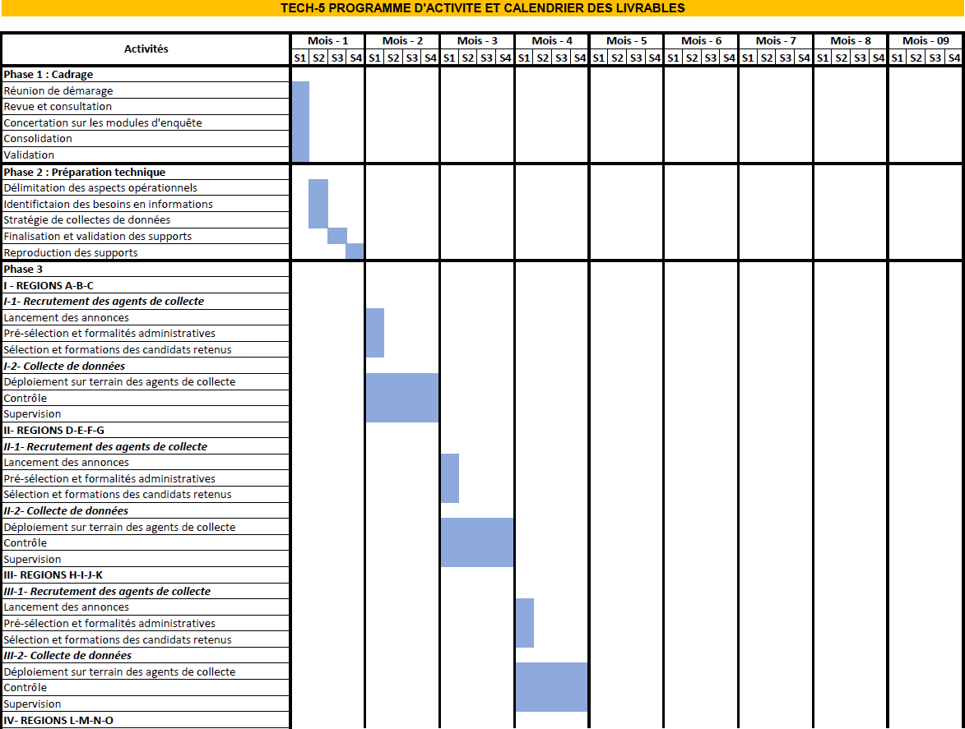

fU'-J - Recruitment of collection agents
Launching advertisements
Pre-selection and administrative formalities
Selection and training of successful candidates
Field deployment of collection age n ts
Cantrô le
Supe rvision
V- REGIONS P-Q-R
W- J - Recroternent des ng ents de collecte
Launching advertisements
Pre-selection and administrative formalities
Selection and training of successful candidates
Field deployment of collection age n ts
Cantrô le
3upe rvision
VI- REGlows s-r-u
vJ -J - Recruiting collection operatives
Launching advertisements
Pre-selection and administrative formalities
Selection and training of successful candidates
Field deployment of ca Ilecte agents
Ca ntró Ie
Supe rvision
Phase4 : Data processing
3a izie and clearance
Treatment
Phase S: Analysis and publication
Study of plausibility
''e rification of international consistencya of results
Phase6 : RestituÒon
Restit u tia n a nd val idatia n workshop
Cans olfdat ion wit h t he remark s from t he ate lier
Deliverables
Note de ca d rage
Technical preparation report
Data collection report
Data processing report
Grassland report
linaI report

Monitoring of data collection operations
Monitoring operations were carried out in close collaboration with MPEB technicians and DRPEBs.

REGIONS | No. of districts | No. of municipalities | Number of interviewers
Analamanga | 7 | 18 | 16
Itasy | 3 | 14 | 18
Amoron I Mania | 4 | 41 | 54
Alaotra Mangoro | 5 | 21 | 32
Haute Matsiatra | 7 | 57 | 28
Betsiboka | 2 | 14 | 26
Ihorombe | 3 | 30 | 22
Atsimo Atsinanana | 5 | 30 | 64
Sava | 4 | 33 | 56
Sofia | 7 | 26 | 64
Diana | 5 | 52 | 146
Fitovinany | 3 | 15 | 36
Atsinanana | 7 | 52 | 122
Vakinankaratra | 7 | 29 | 54
Bongolava | 2 | 8 | 22
Analanjirofo | 6 | 21 | 102
Anosy | 2 | 10 | 62
Atsimo Andrefana | 7 | 19 | 105
Vatovavy | 3 | 12 | 24
Boeny | 6 | 94 | 106
Menabe | 5 | 26 | 66
Melaky | 3 | 17 | 54
Androy | 4 | 23 | 28
TOTAL 2023 | 107 | 662 | 1307
TOTAL 2012 | 77 | 222
Difference | 30 | 440

Cooperation with stakeholders has also involved ongoing refinement of the data collection methodology through exchanges between the firm, the MPEB and the SWIOFish 2 project:
- Working meeting ;
- Sharing information.
Issuance of a certificate of successful completion of the assignment by the respective regional DRPEBs.

STRUCTURE OF ECN AND MAIN RESULTS
  - Socio-economic characteristics of fishing households
    - Spatial distribution of fishing households by region and gender
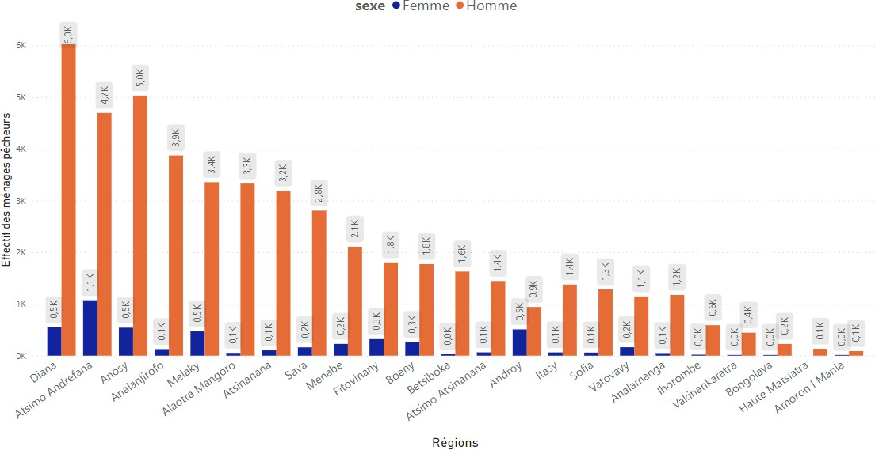
    - Age and gender structures of fishing households
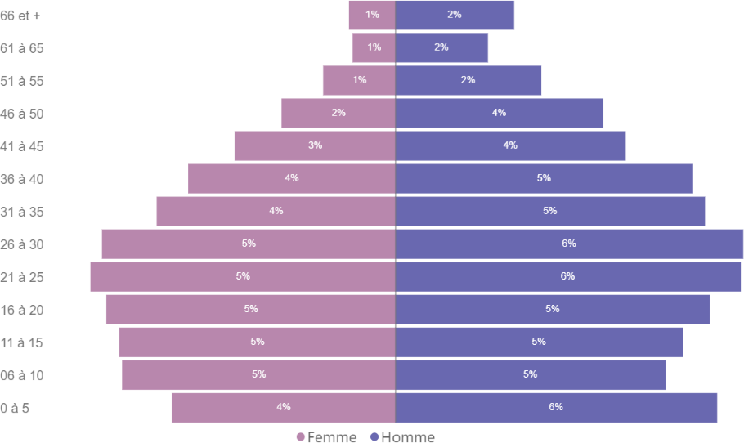
    - Average size of fishing households

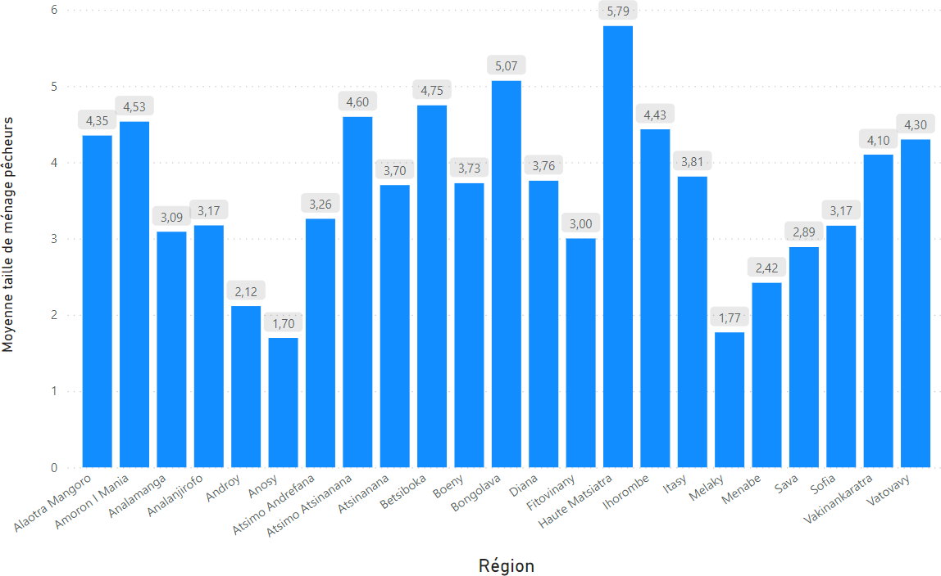
    - Education level of fishing households

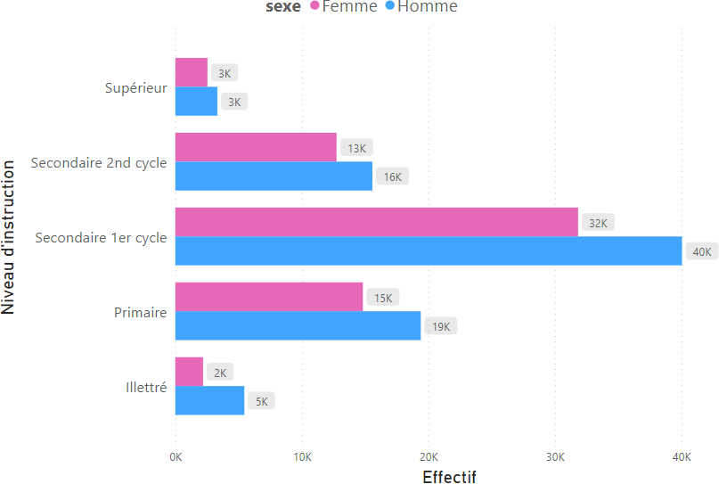
    - Fishing villages

      - Spatial distribution of fishing villages by region
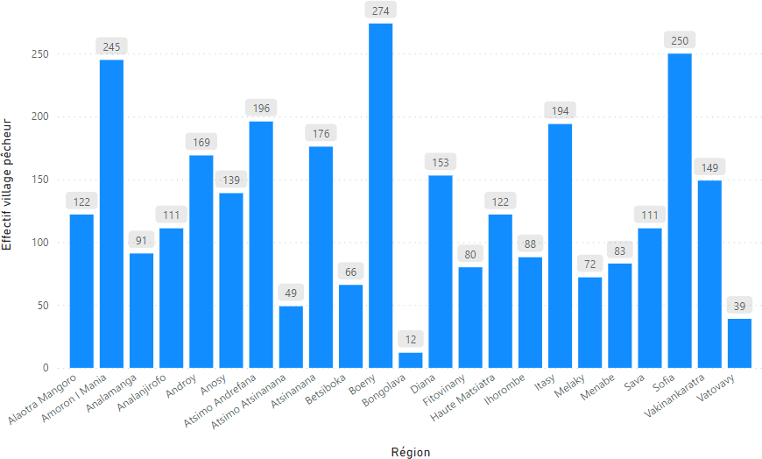
      - Spatial distribution of dugout canoe manufacturers, fishing tackle dealers and fishmongers by region
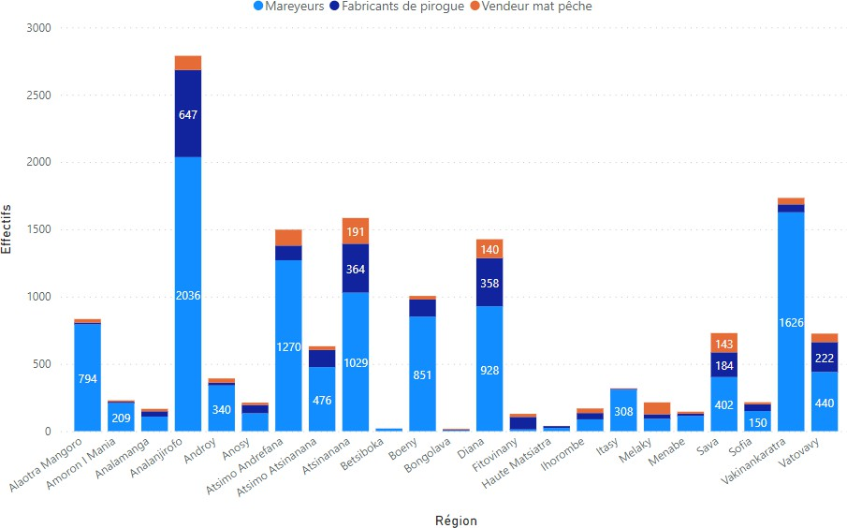

Type of fishery

      - Spatial distribution of marine and inland fisheries by region
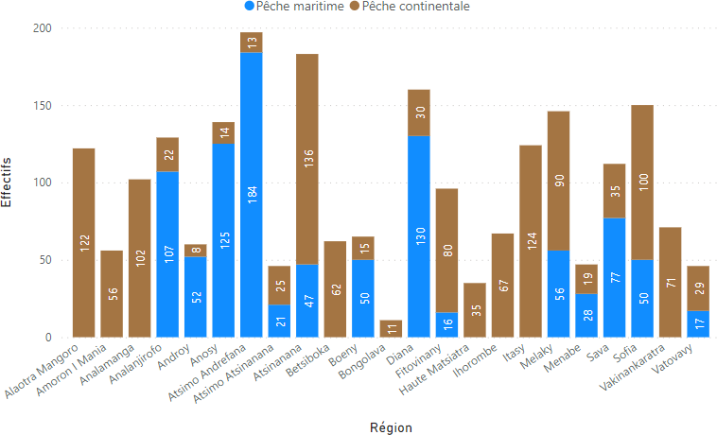
      - Spatial distribution of aquaculture activities by region
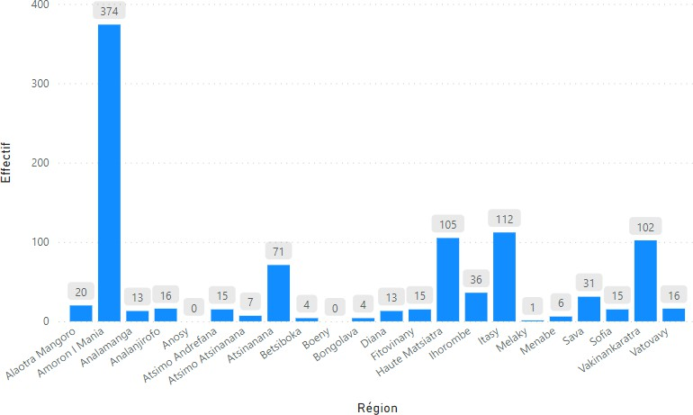
    - Breakdown of landing sites by region

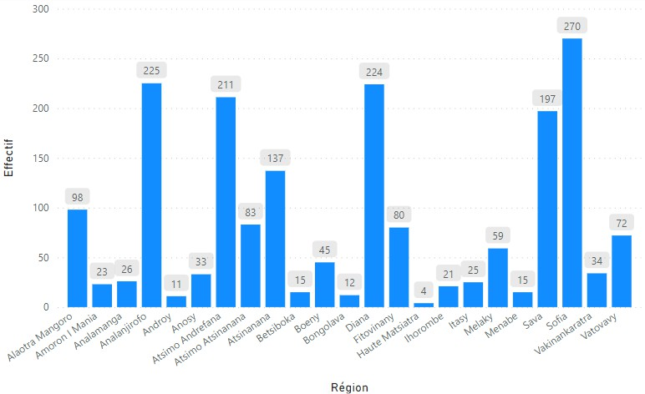
    - Labour force participation rate
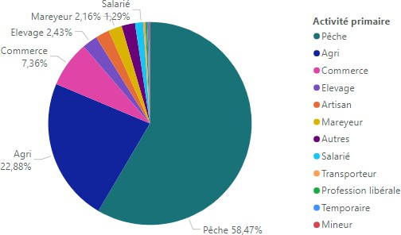

    - Spatial distribution of fishing households in relation to other activities

  - Fishing units
    - Number of anglers by region

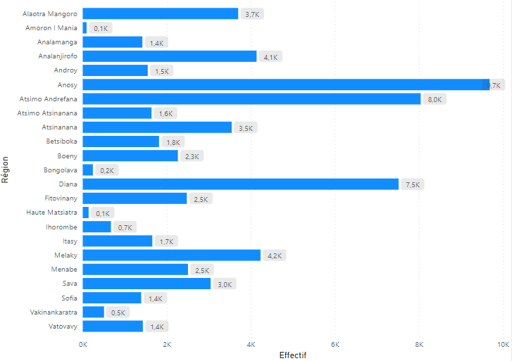
    - Number of anglers by gender, by region
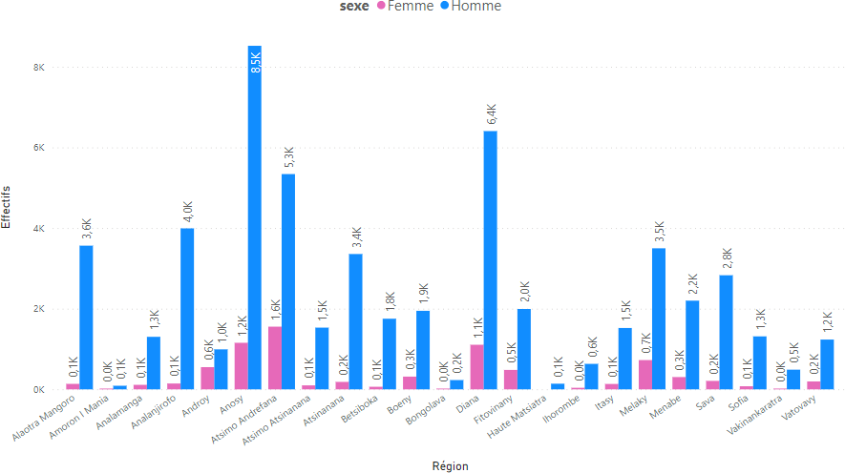
    - Distribution of full-time and part-time fishing activity by region

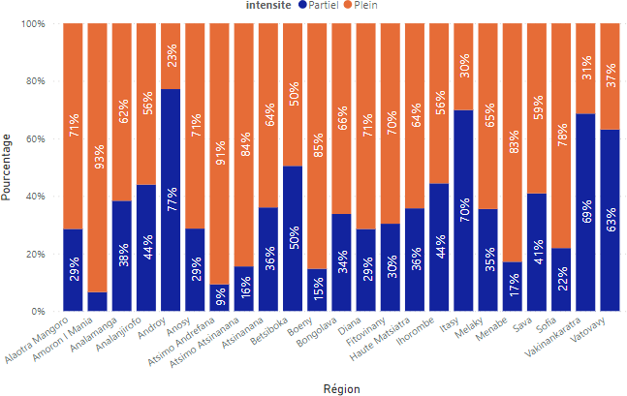

    - Spatial distribution of types of fishermen by region
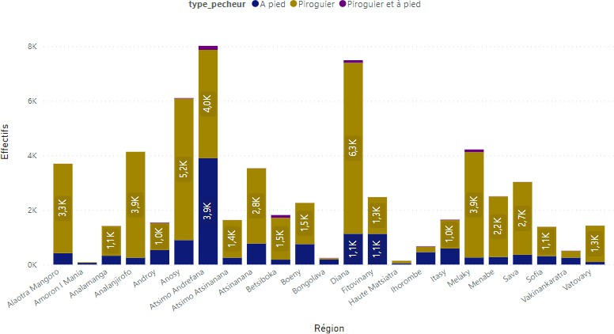

    - Pirogue fishing activities

      - Types of pirogues

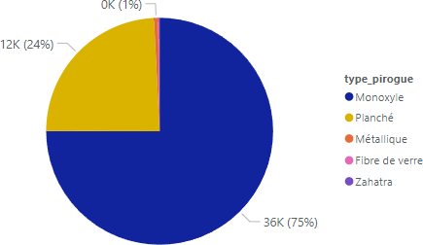

      - Spatial distribution by type of pirogue by region
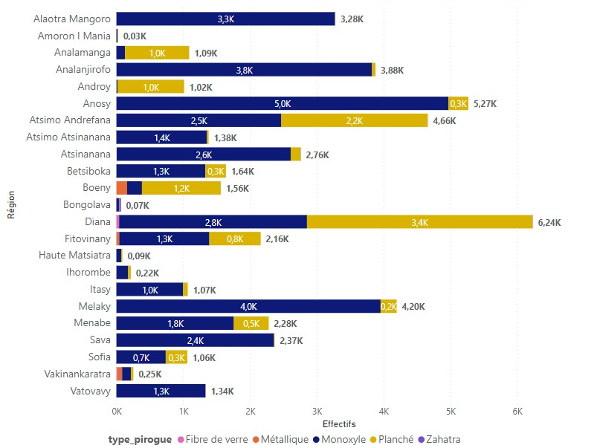

      - Spatial distribution of registered pirogues by region
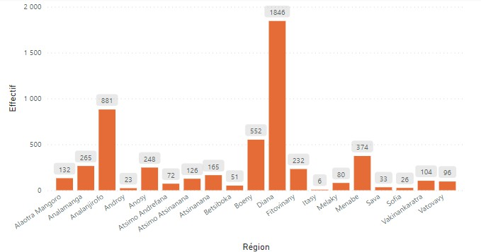

      - Technical characteristics of pirogues: propulsion and motorisation
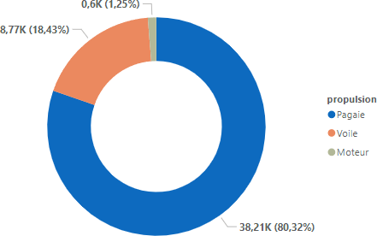

      - Frequency of pirogue fishing activities
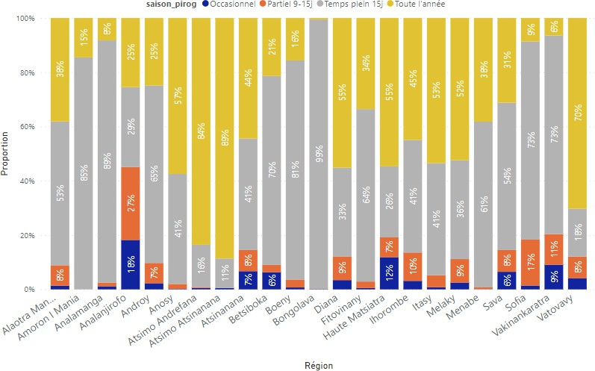
      - Average number of pirogues in fishing units: possession
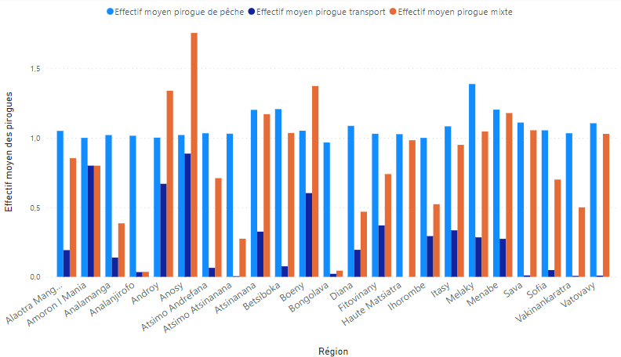
      - Primary and secondary canoeing activities

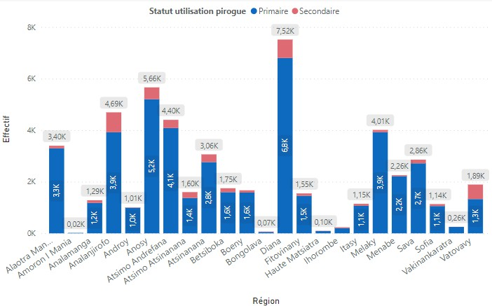

      - Characterisation of pirogue fishing gear Main types of gear
- Fishing lines
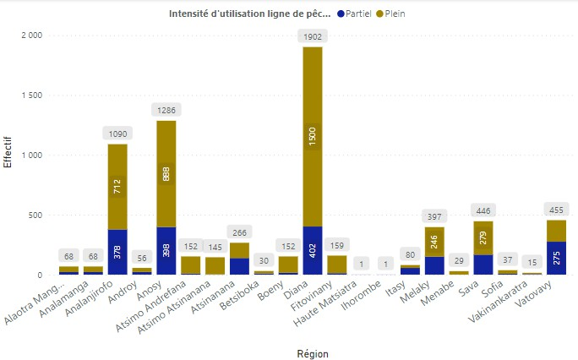

- Nets
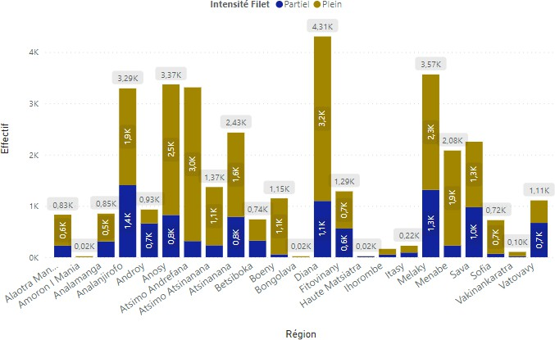
- Nasse - Locker
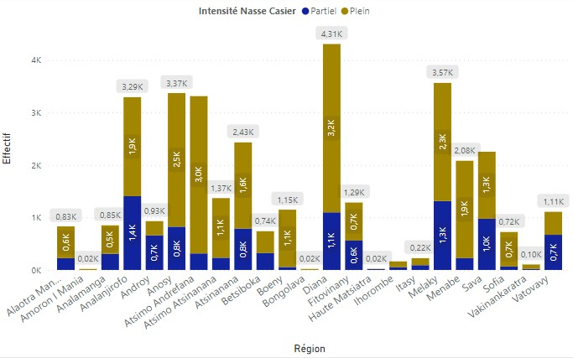

- Dam

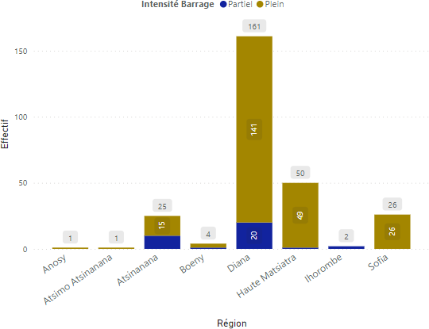
- Mosquito net
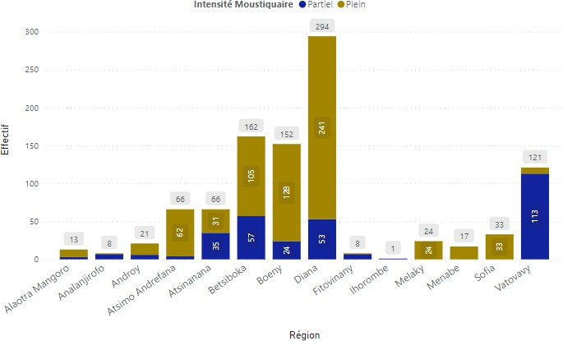

- Sparrowhawk
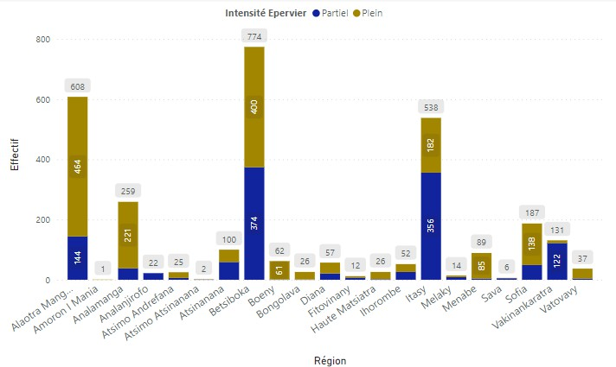
- Harpoon and fish gun
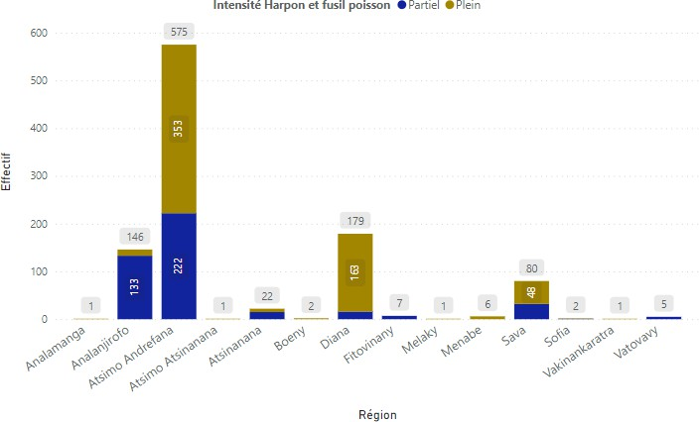
- Diving fishing gear

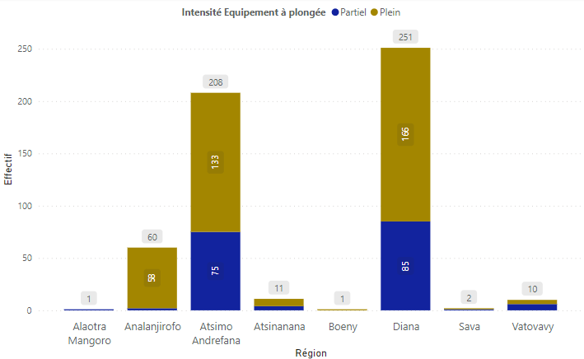
    - Fishing on foot
      - Frequency of fishing on foot
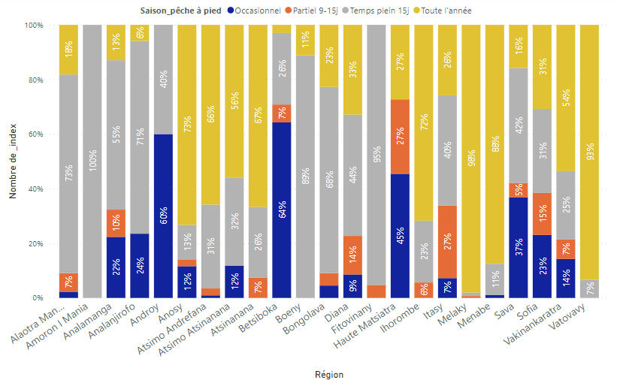

      - Primary and secondary gear for fishing on foot
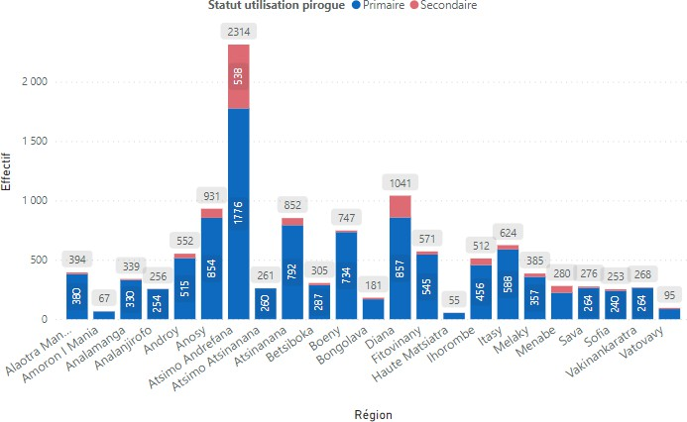
      - Typology and spatial distribution of machinery
- Fishing lines
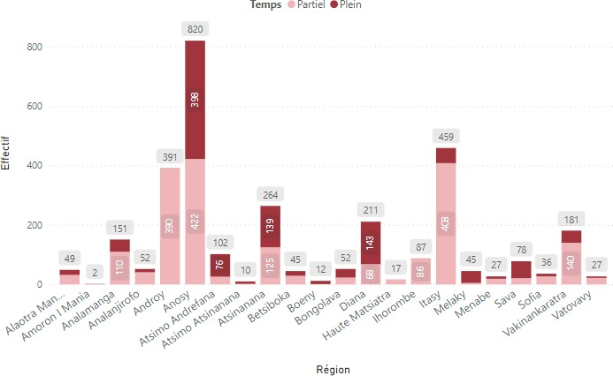

- Nets
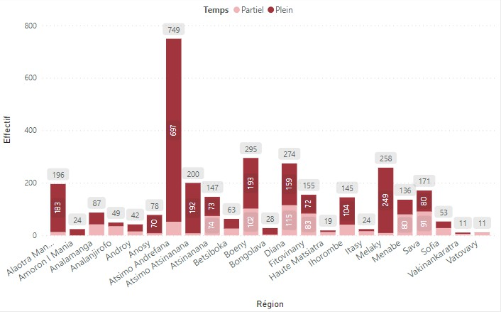
- Nasse - Locker
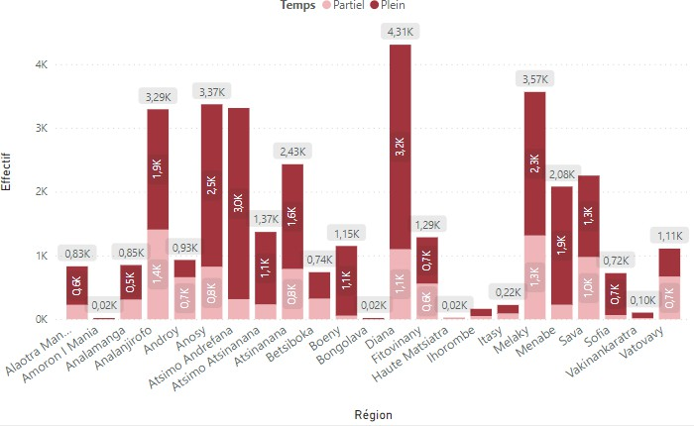

- Diving fishing
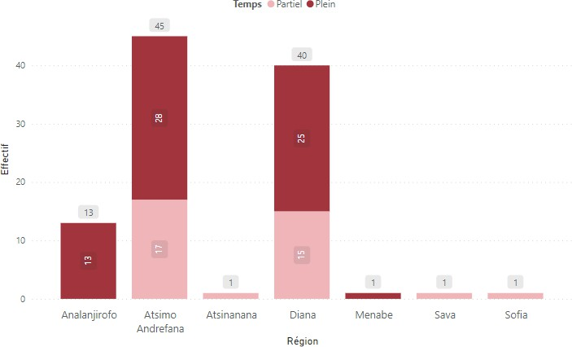
- Crab gear
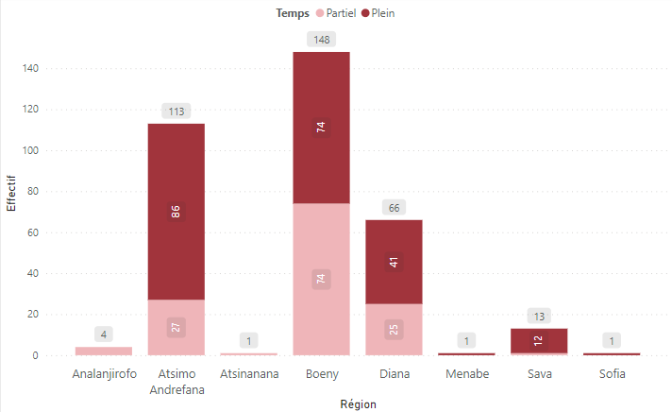
  - Aquaculture activities
    - Spatial distribution of fish farmers

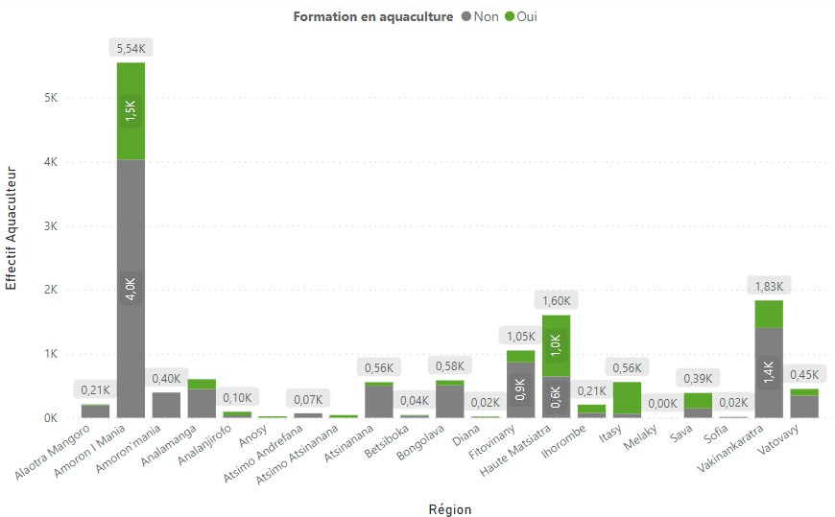
    - Types of aquaculture activity by region
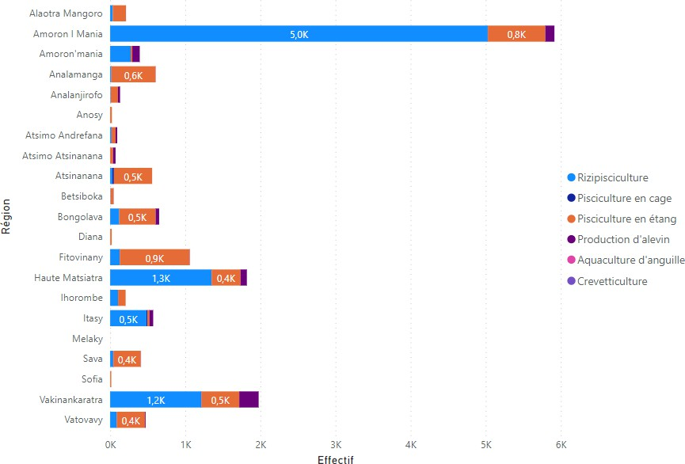
    - Seasonal aquaculture over the course of a year

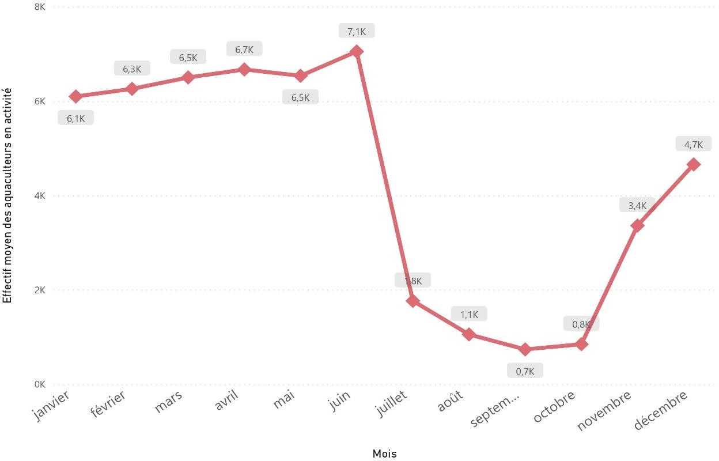
    - Spatial distribution of activities by species
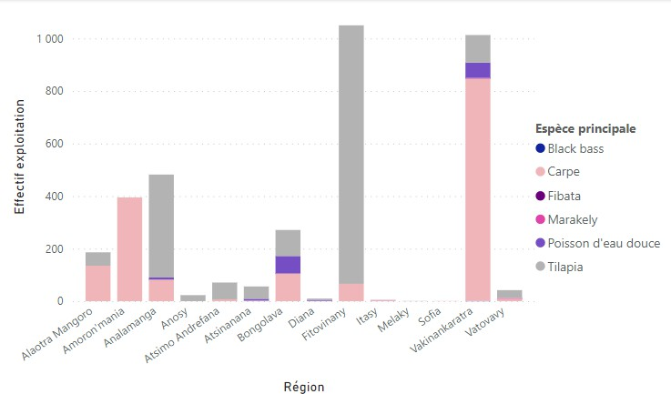
    - Aquaculture production systems: continental aquaculture

      - Pond fish farming

Spatial distribution by species
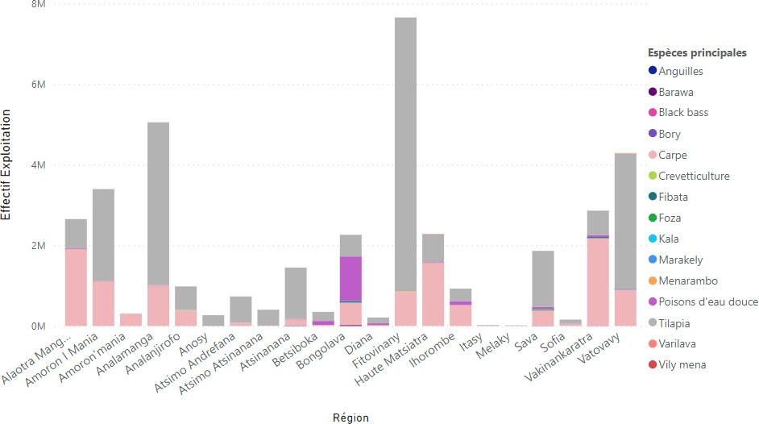
- Lake

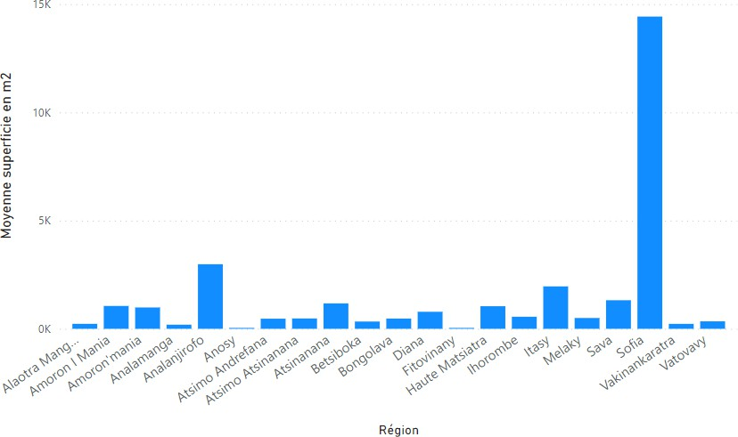

      - Cage fish farming

Spatial distribution by species
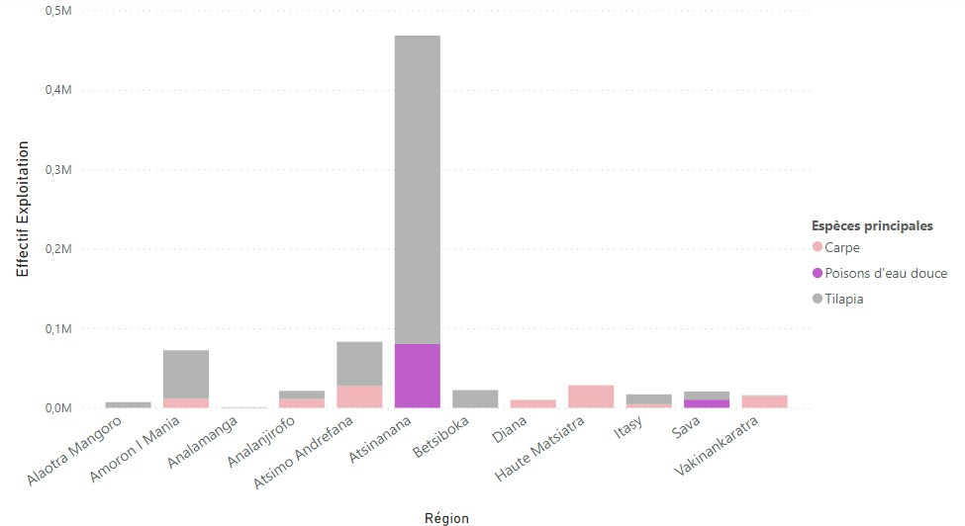
- Water and equipment (surface area and number of cages)
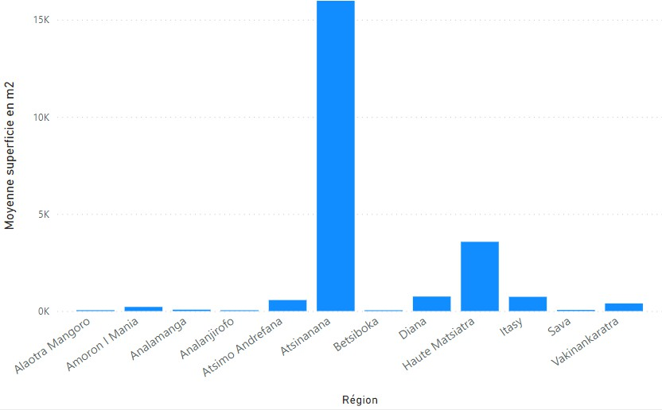

      - Rice-fish farming
- Spatial distribution by species
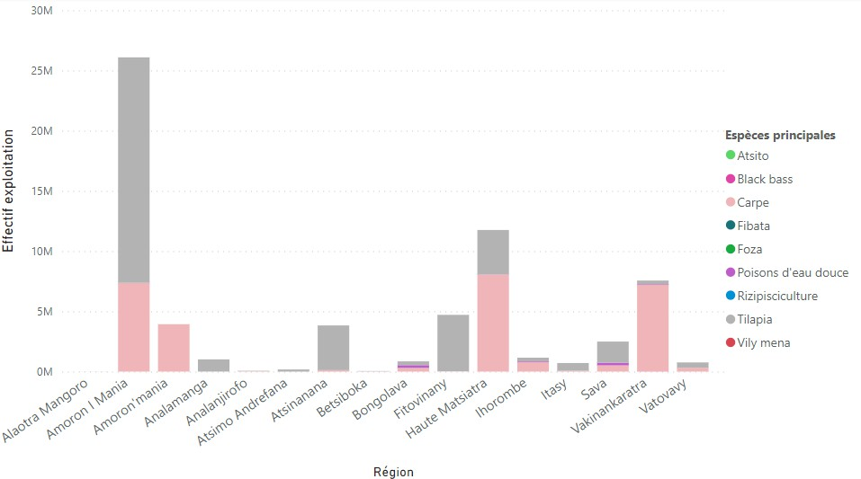
- Water and machinery

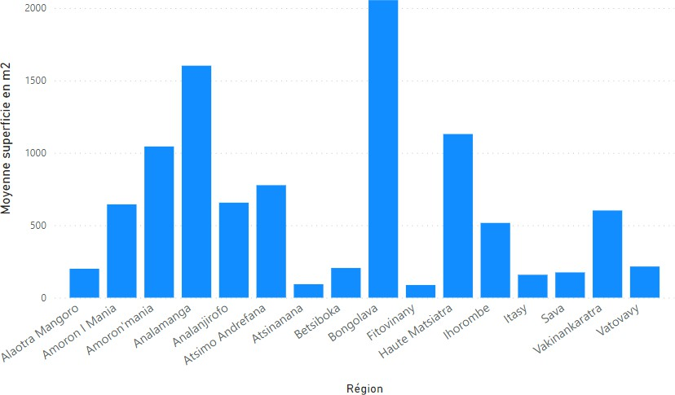
    - Fishing institution

      - Extension institutions by region
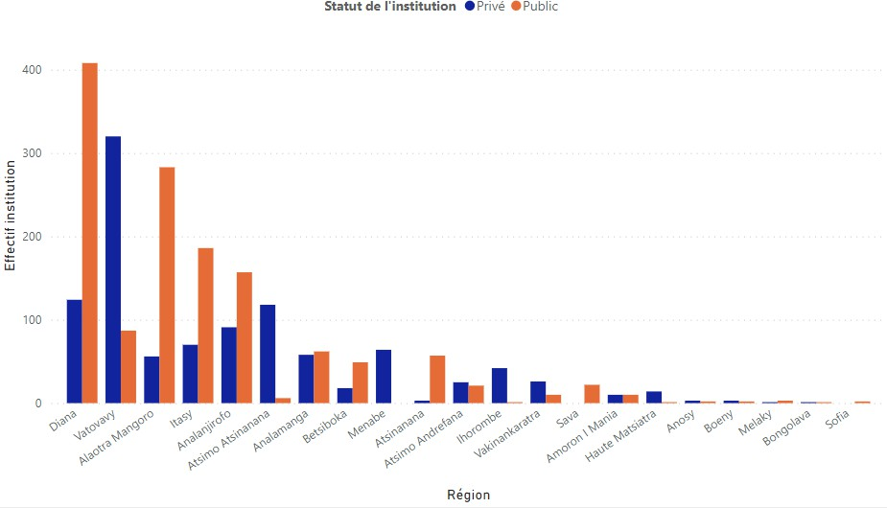
      - Institutional objectives and satisfaction
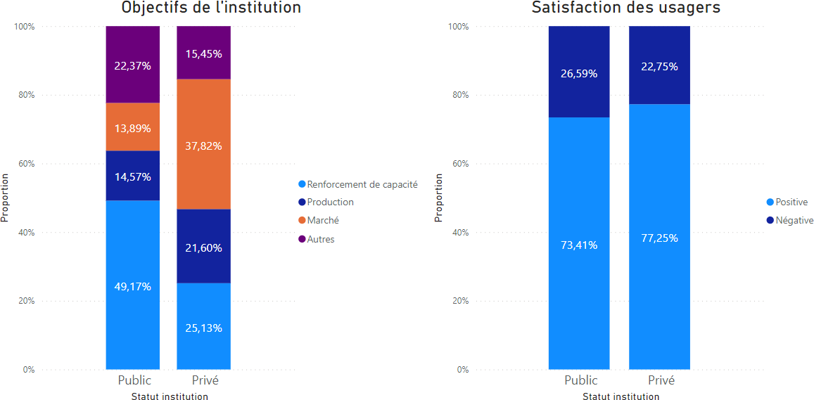

      - Forms of support for aquaculture-related activities
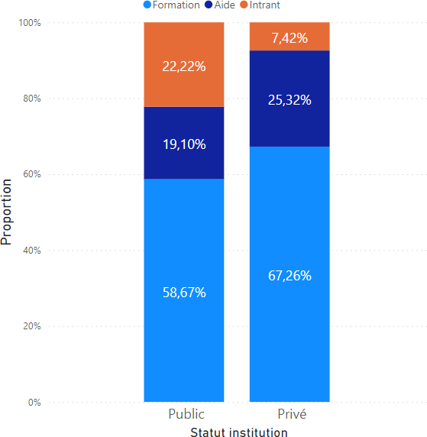

GENERAL CONCLUSION
The National Framework Survey 2023 contributes to improving the management of fisheries resources in Madagascar. This document will also ensure the sustainable development of small-scale marine and inland fisheries, as well as aquaculture, by improving the information system for the fisheries and aquaculture sector. The provision of up-to-date data based on the latest ECN dating from 2012.
It should be noted that the basic data presented in this document have seen the active participation of the Regional Directorates for Fisheries and the Blue Economy in the 23 Regions of Madagascar and the fisheries statistics service. This participatory approach, both in the design and in the collection of data, has been significant, particularly in the verification of actual data and the addition of any necessary supplementary data.
This ECN is also marked by greater coverage in data collection, reaching all Regions, Districts, Communes and even fishing villages throughout Madagascar. In all, 2,587 fishing villages were surveyed. However, while the data from the ECN 2012 were broken down by fishing gear and gender, the data in the ECN 2023 are in most cases aggregated at national level.
The ECN 2023 places particular emphasis on continental aquaculture on a household scale. Marine aquaculture, which is more the preserve of large companies, is not the subject of this study. However, not all fishing gear has been exhaustively inventoried. Data was collected by "gear group" and the analyses are based solely on the results of surveys carried out directly with fishermen/fish farmers.

APPENDICES

LIST OF APPENDICES

Appendix 1: Investigators' manual Appendix 2: Controllers' manual
Appendix 3: Supervisory Agent Manual
Appendix 4: Questionnaire on the identification of fishing villages

Appendix 1: Interviewers' manual



NATIONAL FRAMEWORK SURVEY
INTERVIEWERS' MANUAL



INTRODUCTION

Context of the national framework survey -- ECN

The SWIOFish2 project is a regional project for the development of maritime fishing, particularly small-scale fishing. In Madagascar, it is being implemented by the Ministry of Fisheries and the Blue Economy.
The project is largely financed by the World Bank. The financing agreements were signed on 20 April 2017. The project has three components, namely (i) capacity improvement for the management of priority fisheries, (ii) capacity building for engagement in alternative fishing practices and livelihood activities and (iii) Project Management and Coordination.
The SWIOFISH2 project is a multi-stakeholder project. The Project Management Unit (PMU) is responsible for national coordination. The Local Management Units (UGL) provide this coordination at a decentralised level. The various technical departments of the Ministry of Fisheries and the Blue Economy and the related National Public Establishments are responsible for implementing the activities. Certain activities intended for the project's beneficiaries are implemented by the Implementing Agencies. At this stage, the project is operating in three (3) areas classified as ultra-priority (ZUP), namely (i) Antongil Bay (in the Analanjirofo Region),
(ii) the Bay of Ambaro-Ampasindava (in the DIANA Region) and (iii) the Melaky Region, areas which already have a Fisheries Management Plan (FMP).
In line with its objectives, the project has launched a national framework survey - ECN, providing a comprehensive database on the fishery and production capacity of the small-scale maritime and continental fishing sector in coastal and continental regions. This involves a census of fishermen in the fishing zones identified, updating the framework data for small-scale fisheries in Madagascar.

Objectives of the ECN

The purpose of a framework survey is to provide a reliable and up-to-date database on the small-scale fishing sector with a view to the sustainable management of fishery resources. It constitutes a census (exhaustive survey) of fishermen, focusing on fishing gear, boats and their socio-economic characteristics.
The ECN concerns two types of fishery:

- sea and coastal fishing and,
- fishing in the main inland waters
Consequently, the ECN will be carried out in all of Madagascar's coastal communes and main continental water bodies. A priori, it covers around 222 communes and 180 bodies of water, which are likely to be updated in relation to the land.

THE INVESTIGATOR

Profile of the investigating agent

ECN is carried out by questioning fishermen directly. It calls for personal, technical and operational qualifications on the part of the field agent in terms of how to gather information in a professional manner. This direct interview requires the agent to meet optimum conditions, i.e. the following moral, physical and intellectual qualities:
Quality of the moral order

- Courtesy is an essential condition for carrying out a survey. The interviewer must demonstrate this quality of benevolence towards the interviewer.
- Patience and intelligibility are essential qualities for obtaining complete information. The interviewer must provide the necessary and useful explanations, repeating them if necessary, in order to eliminate problems linked to the respondent's reluctance and/or lack of understanding. Questions should be clear and well formulated.
- Investigation is a scrupulous and delicate operation. Investigators must be honest and conscientious in their work. They must comply with the instructions given to them.
- Survey data is strictly confidential. Any disclosure of information received by the surveyor, outside the ECN framework, is strictly prohibited. The sharing of information is authorised only through capitalisation, monitoring and control by affiliated controllers and supervisors.
- The interviewer is in no way a burden on either the households or the respondents. Any form of remuneration in favour of one of the two parties is strictly forbidden: food, accommodation, etc. His interview is devoid of any promise or commitment.
- The framework survey is carried out correctly and strictly in the villages and/or hamlets of

fishermen. The investigator is required to respect the habits and customs of the area in which he is working and must show respect for local rites and Fady.
- The investigator must carry out his work conscientiously.
Quality of physical order

Optimal physical conditions are required of the interviewer when carrying out fieldwork. Fieldwork requires courage and good health and physical condition. They must be able to cope with field conditions.
They must report any physical shortcomings in the performance of their work (incapacity, illness, accident, etc.) to their line manager.
Intellectual quality

The interviewer must comply with all instructions given to him/her. His services must include :
- Understanding the main objectives of the ECN. He must make himself understood and must understand the ins and outs of his intervention. From the outset of his interview, he must establish the confidence of his interlocutor by presenting the objectives of the ECN, while emphasising that it is carried out neither for tax purposes, nor to control fishing activities, nor for any other compulsory purpose, and all the information provided is and remains confidential.
- Clear questions faithfully translated into comprehensible wording and/or local dialect. This ability is required.
- A critical eye for checking the veracity and/or plausibility of answers. He/she must gather accurate and coherent information. He/she must develop an acute sense of communication.
- Report the information gathered intelligibly, correctly, legibly and cleanly.

The role of the investigating agent

The investigator conducts direct interviews with the survey units, and ensures that the questionnaires reserved for this purpose are completed. This role must be carried out rigorously and meticulously.
Three categories of questionnaires have been drawn up as part of the ECN: firstly, a village survey designed to collect information on the spatio-demographic characteristics of fishing areas; secondly, a survey of fishing households, which is likely to collect information on the spatial and demographic characteristics of fishing areas; and thirdly, a survey of fishing households, which is likely to collect information on the spatial and demographic characteristics of fishing areas.

socio-economic characteristics of households and, finally, a survey of fishermen (survey unit) describing their fishing activities.
The investigating agents work in pairs and organise themselves as efficiently as possible.

USEFUL TIPS

Introductory phase

As soon as they arrive in a commune, village or hamlet, the agents must introduce themselves to the mayors, chiefs and notables (Tangalamena, Mpitankazomanga, fokontany chief), providing the necessary administrative documents if necessary. This phase is a key condition for the successful completion of the survey work in the zones. The agents present and explain the purpose of their work and provide the necessary explanations, which may in turn be a means of extracting as much information as possible from these officials. The latter may in turn provide guidance or additional information for the ECN.

Investigation phase

General framework

The agent must be courteous and present the reason for the visit appropriately. They establish a relationship of trust by eliminating any reluctance on the part of the person they are talking to (avoid negative communication and restrictive behaviour). For example: avoid saying, "We're here because we've heard that..."; avoid playing telephone games and taking sound recordings.
Make sure that the interview location is chosen by the respondent and that he/she does not immediately go about his/her business. Ask kindly for their agreement and work at their ease.
The interview takes around twenty minutes on average and should take place away from prying eyes wherever possible.
Under no circumstances can the agent force people to provide information.
Nor is it a project leader. Avoid any communication evoking a resolution of

problem, nor make any reference to any commitment to the respondents.
Questionnaire skills

The agent must master the various questions on the survey forms. This is a prerequisite for any interview and leads to quality work. The interviewer carries out his role objectively. In other words, they are able to resolve any problems that may arise.
Direct interview
Once a climate of trust and serenity has been established, open the discussion by asking the questions in the order recorded in the questionnaires.
Questions should be brief, clear and concise. Never interrupt the speaker.
Pay close attention to the answers before recording them on the support provided.
When the other person rambles or gets lost, refocus the discussion in a courteous and straightforward manner.
The survey forms must be completed during the interview. They may not be completed after the interview.

THE ECN ITSELF

The actual survey work is carried out in two dependent ways: the enumeration of fishing villages and the survey of households and fishing units.

Census of fishing villages

This is a preliminary operation to the ECN in order to identify the fishing households in the village and/or hamlet within which the fishing units will be surveyed. This phase involves gathering information on the spatial and demographic characteristics of the area and the socio-economic characteristics of the households. It provides information on the fishing activities of households: types of fishery and sites.

Household survey

The households identified during the village enumeration are the subjects of the household survey. To save time, the interview can be conducted by a single interviewer, while the measurements must be carried out in pairs.

Survey of fishermen

The primary units in the ECN are fishermen. It takes an (exhaustive) census of fishermen in the areas identified in the village census. It collects information on fishermen, types of fishing, fishing gear and the production system of the small-scale maritime and inland fishing sector.

Survey forms

The survey forms are the tangible support for the interviewer's work. They must be filled in meticulously: intelligible, clear and clean.
Use blue or black pens.
Coding must be in accordance with the relevant directives. All questions must be answered appropriately.

CONTROL AND SUPERVISION
They are the hierarchical superiors of the interviewers, while the controllers and supervisors are responsible for ensuring the reliability of the data collected and the progress of the data collection phase in the field. They are involved in monitoring and control on an ad hoc basis, and have privileged and permanent contact with the investigators.
They must have the moral, intellectual and physical qualities to carry out their roles successfully.
The supervisor is responsible for the overall coordination of the work carried out during the various phases of the survey. He/she manages the administrative (introduction to the authorities), technical and logistical phases of the fieldwork.
It provides recommendations and intervenes when problems arise:
- Helping the interviewer to solve any technical or material problems,

- Be able to give advice to the investigator and correct any mistakes. However, in the event of serious misconduct, they must not hesitate to punish the interviewer if necessary,
- Manage materials and questionnaires (data files),
- Controlling and monitoring the work of the investigators,
- Check data quality

CONCEPTS AND DEFINITIONS

Village census

Village: term used to describe the fisherman's place of residence. It may be a hamlet or a temporary or permanent camp. Translation: tanàna/vohitra/fokontany
Types of fishery: designating the characteristic aspects of fishing activities linked to the fishing environment, which can be broken down into three types: marine fisheries, inland fisheries (river, lake, lagoon and both marine and inland (estuary)) and aquaculture.
Pirogue maker: a craftsman who makes, designs and builds a pirogue, essentially a monoxyle pirogue. (A tree trunk is felled to make a monoxyle pirogue).
They differ from shipwrights, who use wooden planks or metal plates as their raw material.

Fishing tackle salesperson: an individual who sells fishing tackle such as nets, lines, hooks, etc. either wholesale or retail.
Mareyeur: traders who buy and sell fishery products within a single collection area.
Collectors: any individual who buys fish products directly from fishermen and/or wholesalers.
Mangrove: (honko) dense forest in tropical areas by the sea, mainly in the north, south and west coast of Madagascar.
Landing site: (seragna, saragna) place where fishermen dock and land their catch. It is also a place for marketing and other operations such as stowing gear,...

Housing unit: (trano fonenana) the house used as a dwelling Household: (ankohonana) group of individuals living under the same roof
Head of household: the natural person, man or woman, responsible for the socio-economic and financial affairs of a household.
Household size: defined by the number of individuals in the household

Household survey

Use of pirogues: functional forms identified by pirogues (fishing, transport, hire)
Vocational training in fishing: formal and informal capacity-building for fishermen
Fishing gear: a set of tools used to catch fish products.
- Net: a network of meshes of different sizes. It is a passive capture device.
- Gill net
- Sennes
- Traditional trawl net
Fishing line: a set of wires (mother line) and hooks, baited or unbaited depending on the fishing technique.

Boat :
- Types of boat: monoxyl with outrigger (lakam-bezo) and without outrigger (laka molanga), made of plank or sheet metal
Type of propulsion: refers to the source of energy with which the boat is powered (paddle, sail, engine).
Depth of the boat: measurement taken from the inside in the middle of the boat

Appendix 2: Controllers' manual

NATIONAL FRAMEWORK SURVEY
CONTROLLERS' MANUAL

- INTRODUCTION

Context of the national framework survey -- ECN

The SWIOFish2 project is a regional project for the development of maritime fishing, particularly small-scale fishing. In Madagascar, it is being implemented by the Ministry of Fisheries and the Blue Economy.
The project is largely financed by the World Bank. The financing agreements were signed on 20 April 2017. The project has three components, namely (i) capacity improvement for the management of priority fisheries, (ii) capacity building for engagement in alternative fishing practices and livelihood activities and (iii) Project Management and Coordination.
The SWIOFISH2 project is a multi-stakeholder project. The Project Management Unit (PMU) is responsible for national coordination. The Local Management Units (UGL) provide this coordination at a decentralised level. The various technical departments of the Ministry of Fisheries and the Blue Economy and the related National Public Establishments are responsible for implementing the activities. Certain activities intended for the project's beneficiaries are implemented by the Implementing Agencies. At this stage, the project is operating in three (3) areas classified as ultra-priority (ZUP), namely (i) Antongil Bay (in the Analanjirofo Region),
(ii) the Bay of Ambaro-Ampasindava (in the DIANA Region) and (iii) the Melaky Region, areas which already have a Fisheries Management Plan (FMP).
In line with its objectives, the project has launched a national framework survey - ECN, providing a comprehensive database on the fishery and production capacity of the small-scale maritime and continental fishing sector in coastal and continental regions. This involves a census of fishermen in the fishing zones identified, updating the framework data for small-scale fishing in Madagascar.

Objectives of the ECN

The purpose of a framework survey is to provide a reliable and up-to-date database on the small-scale fishing sector with a view to the sustainable management of fishery resources. It constitutes a census (exhaustive survey) of fishermen, focusing on fishing gear, boats and their socio-economic characteristics.
The ECN concerns two types of fishery:

- sea and coastal fishing and,
- fishing in the main inland waters
Consequently, the ECN will be carried out in all of Madagascar's coastal communes and main continental water bodies. A priori, it covers around 222 communes and 180 bodies of water, which are likely to be updated in relation to the land.
- CONTROLLER

Profile and general tasks of the control officer

ECN is carried out by questioning fishermen directly. It calls for personal, technical and operational qualifications on the part of the field agent in terms of how to gather information in the proper manner. The tasks assigned to inspectors require the agent to meet optimum conditions, i.e. moral, physical and intellectual qualities. They must at least have worked as investigators.
Intended for ECN control officers, this manual is an essential support tool for the smooth running of their duties. It sets out their instructions and responsibilities.
Specifically, the role involves :
- Organise and monitor data collection operations as a whole, proposing general and/or specific guidelines;
- Visit and raise awareness among administrative authorities through courtesy visits,
- Be the main contact for local authorities
- Coordinate field operations
- Checking and monitoring work on site through unannounced visits,
- Distribute and centralise questionnaires and forward them to the central level,
- Validate the collection agents' reports,
- Managing and collecting materials and questionnaires.
- Checking the quality of the investigating agents' reports. These responsibilities require the agent to have the following qualities:
- Coordination and organisational skills. Provides practical advice to investigators.
- Proactive
- Rigorous and disciplined
- A sense of responsibility

- A facilitator capable of finding solutions to difficult situations
In coordination with the supervisor, he introduces and presents the collection agents to the local authorities. It is therefore recommended that they make contact with local notables and officials as soon as they arrive in their areas of operation.

Management of materials and questionnaires

The controller is responsible for the proper use of all equipment used in the field and made available to agents. His responsibilities include :
- Distribution of questionnaires and survey materials,
- Collection of completed questionnaires,
- Recovery of all materials at the end of the work.
The controller must justify his tasks by filling in follow-up sheets for the management of materials and questionnaires.

Breakdown of investigators

In coordination with the supervisor, the controller introduces the investigators to the local authorities and places them in their areas of operation in accordance with the directives. He also provides explanations to field managers on the objectives and progress of operations in relation to the ECN. If necessary, he can invoke the latter.

Controlling and monitoring the work of investigators

The main task of the control officers is to monitor and control the activities carried out by the investigators. Control missions aim to :
- Optimal management of the investigators under its responsibility (compliance with recommendations and work discipline).
- Effectively managing and coordinating all operations to meet distributed deadlines by setting the right pace,
- To support the investigation officers in the event of technical and/or operational difficulties and to provide appropriate solutions. Each situation generating difficult cases must be recorded in the report sheets.
- Ensuring the quality of the data collected.
Control and monitoring activities essentially comprise :
- Checking that investigators are present on site,

- Control and monitoring of work carried out by investigators
- Checks on compliance with operating schedule,
- Checking the accuracy and consistency of the information provided in the media.

CONTROL OF THE PRESENCE OF INVESTIGATORS ON SITE

The field supervisor is primarily responsible for ensuring that data is collected effectively in the field. To this end, it is imperative that he/she controls the survey agents who may intentionally fill in questionnaires without any information. He/she must check that the interviewers are physically present on site, as recorded on a card.

CONTROL FROM THE QUALITY FROM WORK FROM INVESTIGATION AGENTS

As a key support for the investigators, the controller carries out detailed monitoring and checks on the consistency of the information collected on the survey forms: compliance and control when filling them in.

ADHERENCE TO OPERATING SCHEDULE

The controller must ensure that the timetable for operations is strictly adhered to. If the timetable is not adhered to, he must impose appropriate instructions.

MANAGEMENT OF FILLING DEFECTS

In order to avoid any form of bias in filling in the forms provided by the interviewers (errors and omissions), the controller must carry out permanent and exhaustive monitoring and verification.
It carries out a technical check of the documents:
- Make sure there are no no-answers on the forms,
- Cross-checking and verification of information supplied,
- Check that the codes are consistent with the information given.

REPORT

The controller performs :
- A systematic report using the appropriate support,

- A periodic report on field operations,
- In the event of difficulties encountered or potential problems, a report on the situation outlining the cases and the solutions found.

Appendix 3: Supervisory Agent Manual

NATIONAL FRAMEWORK SURVEY
SUPERVISORY AGENT MANUAL

- INTRODUCTION

Context of the national framework survey -- ECN

The SWIOFish2 project is a regional project for the development of marine fisheries, particularly small-scale fishing. In Madagascar, it is being implemented by the Ministry of Fisheries and the Blue Economy.
The project is largely financed by the World Bank. The financing agreements were signed on 20 April 2017. The project has three components, namely (i) capacity improvement for the management of priority fisheries, (ii) capacity building for engagement in alternative fishing practices and livelihood activities and (iii) Project Management and Coordination.
The SWIOFISH2 project is a multi-stakeholder project. The Project Management Unit (PMU) is responsible for national coordination. The Local Management Units (UGL) provide this coordination at a decentralised level. The various technical departments of the Ministry of Fisheries and the Blue Economy and the related National Public Establishments are responsible for implementing the activities. Some of the activities intended for the project's beneficiaries are implemented by Implementing Agencies. At this stage, the project is operating in three (3) areas classified as ultra-priority (ZUP), namely (i) Antongil Bay (in the Analanjirofo Region),
(ii) the Bay of Ambaro-Ampasindava (in the DIANA Region) and (iii) the Melaky Region, areas which already have a Fisheries Management Plan (FMP).
In line with its objectives, the project has launched a national framework survey - ECN, providing a comprehensive database on the fishery and production capacity of the small-scale maritime and continental fishing sector in coastal and continental regions. This involves a census of fishermen in the fishing areas identified, updating the framework data for small-scale fishing in Madagascar.

Objectives of the ECN

The purpose of a framework survey is to provide a reliable and up-to-date database on the small-scale fishing sector with a view to the sustainable management of fishery resources. It constitutes a census (exhaustive survey) of fishermen, focusing on fishing gear, boats and their socio-economic characteristics.

The ECN concerns two types of fishery:
- sea and coastal fishing and,
- fishing in the main inland waters
Consequently, the ECN will be carried out in all of Madagascar's coastal communes and main continental water bodies. A priori, it covers around 222 communes and 180 bodies of water, which are likely to be updated in relation to the land.
- OF THE SUPERVISOR

Supervisor profile

Intended for supervisors recruited as part of the ECN, this handbook provides essential support for the smooth running of their assignments. It sets out their instructions and duties.
The supervisor's primary responsibility in the field is to supervise all data collection operations in the field. They carry out ad hoc assignments depending on the conditions prevailing in the field.
Specifically, the role involves :
Organise and monitor overall data collection operations by proposing global and/or specific guidelines;
- Visit and raise awareness among administrative authorities through courtesy visits,
- Be the main contact for local authorities
- Coordinate field operations
- Checking and monitoring work on site through unannounced visits,
- Distribute and centralise questionnaires and forward them to the central level,
- Validate the collection agents' reports,
- Managing and collecting materials and questionnaires.
- Check the quality of the investigating agents' reports.
These responsibilities require the supervisor to have the following qualities:

- Coordination and organisational skills. Provides practical advice to investigators.
- Proactive
- Rigorous and disciplined
- A sense of responsibility
- Facilitator and capable of finding solutions in difficult situations

The supervisor introduces the collection agents to the local authorities. They are therefore advised to make contact with local notables and officials as soon as they arrive in their areas of operation.
They must have the moral, intellectual and physical qualities to carry out their roles successfully.
The supervisor is responsible for the overall coordination of the work carried out during the various phases of the survey.

Organisation of work

The supervisor is responsible for all operations required to ensure the smooth running and success of data collection operations in the field. He/she must therefore ensure that the following tasks are carried out scrupulously:

DISTRIBUTION OF DATA COLLECTION TEAMS

The allocation of teams is established in advance at the preparatory workshop. This breakdown is indicative and aims to achieve a fair distribution of workloads. It is not set in stone and the supervisor can modify it if necessary.
The supervisor is responsible for organising the interviewers into pairs. Preferably, the pair should be mixed, but this is not compulsory. If, during the survey, the supervisor observes problems of a relational nature that could hinder the smooth running of the collection operations, he/she may reorganise the teams by rearranging the pairs of interviewers. In the event of an interviewer's absence, the supervisor will take the necessary steps by notifying those in charge at central level.

DISTRIBUTION OF QUESTIONNAIRES

The supervisor is responsible for the logistics of data collection operations. At the start of the survey, he/she distributes batches of questionnaires sufficient for a given period to the interviewers from the outset. The supervisor ensures the systematic and regular supply of these materials.
He/she collects the completed questionnaires, duly checked by the controllers, and forwards them to those responsible (Regional Management and/or at central level).

MANAGEMENT OF MATERIAL RESOURCES

The ECN requires measuring equipment. The supervisor ensures that the equipment made available to the collection teams is properly managed and used. Note that faulty measuring equipment is a source of irreparable errors. The supervisor must also monitor the use of motorbikes by the inspectors. Note that these motorbikes will be used in all the regions covered by the framework survey.

ADHERENCE TO TIMETABLE

Collection operatives work for a period of 30 days. This deadline must be strictly adhered to. If it is exceeded, both the enumerators and the general organisation of the data collection are penalised. The interviewer's mission is not completed until all the villages/hamlets and fishermen's households have been surveyed. Consultants
any overrun of the execution time is at their expense, and may even be penalised. It is therefore up to the supervisor to ensure that the schedule is strictly adhered to and to take any necessary measures.

CONTROL AND MONITORING

Unlike controllers, supervisors intervene on an ad hoc basis. The supervisor carries out unannounced checks in the field to ensure that the agents are actually present. Similarly, they only carry out checks on questionnaires drawn at random from the batch of completed questionnaires.
In addition, the supervisor completes his check by talking to the resource persons in the village. He must ask these people about the collection agents' activities, their actual presence, etc.
It checks the presence of the numbers affixed by the agents to the walls or doors of households in villages already surveyed.

VALIDATION OF COLLECTION AGENT REPORTS

Collection operatives are recruited as service providers. Payment of their salaries is conditional on completion of the work entrusted to them. To this end, collection operatives must draw up an activity report at the end of their assignment, which they will submit to

for validation by the supervisor. Report templates are appended to this manual. On the basis of the information available, the Supervisor validates or does not validate the report. If the report is not validated, it is returned to its authors with comments and observations for correction. Validated reports constitute supporting documents for the payment of salaries.

OUTREACH AND FACILITATION
In addition to the information disseminated through the media and the materials displayed on the ECN, it is the supervisor's responsibility to publicise the survey wherever necessary. He contacts the administrative and customary authorities (mayors, Fokontany chiefs, Tangalamena, Lonake, etc.). To this end, it communicates and explains:
- The aim of the framework survey ;
- The work to be done and how to do it;
- The sequence of operations, specifying the various stages and the formation of teams;
- The absence of a link between the national framework survey, taxation and fisheries control (CSP)
- And the confidential nature of the information collected.
N.B.
Don't forget to thank them and ask for their help, especially logistically, if it would make the work of the collection staff easier.

ADMINISTRATIVE AND LOGISTICS MANAGEMENT
Collection operatives work for a period of 30 days. They are not entitled to days off or even leave. As part of this survey, arrangements have been made for the agents to receive an advance, in the form of an allowance, which will enable them to survive for the duration of their missions in the field. It is up to the supervisor to manage this advance in the best possible way (to avoid any ill-considered action that could compromise the progress of field operations, at the risk of harming the investigating agents).
The supervisor manages the payment statements (expense vouchers) in accordance with the guidelines.
At the end of the collection, all the survey materials must be recovered and returned to Antananarivo to be assigned to other regions.

USEFUL TIPS

Mission order

A mission order must be drawn up for each surveyor. Investigators should be asked to have the OM signed by the Fokontany chief when they visit the village.

Letter of introduction

At least each team must have a letter of introduction issued by the Director at regional level. This letter must contain :
- The mission statement,
- The duration of the assignment,
- The area in which the team will be working (names of Communes),
- The names of the agents making up the team.

National identity card

Investigating officers must never separate from their national identity card during the entire collection period. If necessary, the letter of introduction must be presented with the identity card.

Management of the imprest account

You are provided with an advance fund to cover the travel expenses of collection agents. This advance fund must be managed optimally according to the real needs of each agent. It is by no means a salary supplement. Each use of the imprest account must be supported by documentary evidence. A model form to be completed to serve as supporting documentation is provided in the appendix. This form must be systematically approved by the Mayor or the Head of the Fokontany.

CONCLUSION

The tasks assigned to a supervisor are crucial to the success of the ECN. You are therefore asked to carry out these tasks in the best possible conditions. Draw on your personal, intellectual and moral qualities to carry out the ECN effectively and in accordance with its objectives.
So we're calling on your skills, your seriousness and your goodwill.

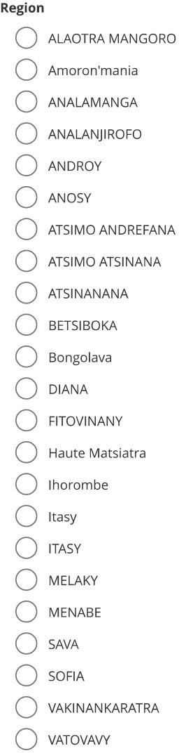
Appendix 4: Questionnaire on the identification of fishing villages

